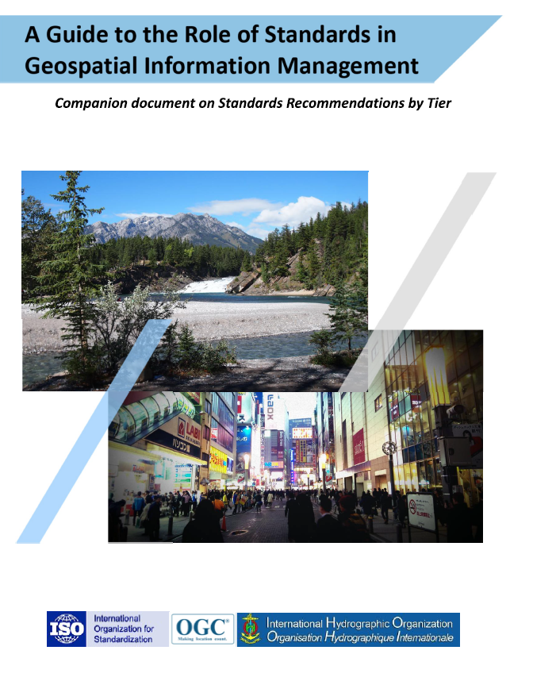

Contents

**Summary** 4

**Introduction** 5

**1.** **Direction Setting** 11

**Standards Awareness** 11

**Emerging Standards and Trends** 23

**Strategy for Standards Implementation** 23

**2.** **Understanding [Organizational Standards] Needs** 28

**User Needs Perspectives** 29

**Managing geospatial data lifecycle** 32

**Functions and Needs by Tier** 33

**3.** **Planning for Change** 39

**Institutional Arrangements** 40

**Action Plan** 43

**4.** **Taking Action** 45

**Implementation** 45

**Foundational Standards** 45

**Tier 1 - Share Maps Internally and Over the Web** 46

**Tier 2 - Geospatial Information Partnerships** 49

**Tier 3 - Spatially Enabling the Nation** 53

**Tier 4 – Future Capabilities: Spatial Data integrated with Global Data Ecosystem** 61

**5.** **Ongoing Management** 70

**Standards Review Program** 71

**Communities of Practice** 72

**6.** **Achieving Outcomes** 74

**Putting it all together** 75

**Compliance** 75

**Success Indicators** 76

**Standards Training, Tools and Related Resources**  77

**Education / Training** 78

**Strategic Goals and Planning** 78

**Standards Baseline Surveys / Assessment** 79

**A Standards Governance Framework** 79

**Action Plans including Institutional Arrangements** 79

**Success Indicators for Benefits Realization** 80

# **Summary**

The purpose of this Guide is to promote the recommendations regarding the use of standards for geospatial information management. The Guide complements [Strategic Pathway 6 on Standards (SP6)](http://ggim.un.org/IGIF/part2.cshtml) of the [Integrated Geospatial Information Framework (IGIF)](http://ggim.un.org/IGIF/) Implementation Guide,

providing specific guidance and options to be taken by countries when implementing the IGIF. This Guide and the IGIF have been developed through extensive consultations with experts from around the world working under the auspices of the United Nations Committee of Experts on Global Geospatial Information Management (UN-GGIM).

This Guide provides detailed insights on the standards and good practices necessary to establish and maintain geospatial information management systems that are compatible and interoperable with other systems within and across organizations. The Guide also underscores the importance of standards in facilitating the application of the FAIR (Findable, Accessible, Interoperable, and Reusable) data principles - promoting improved policymaking, decision making and government effectiveness in addressing key social, economic, and environmental topics, including attainment of Sustainable Development Goals.

The Guide addresses different target audiences and the roles they play in performing implementations of standards, while raising awareness of the benefits and costs of engagement:

* **Decision makers** - who need guidance and coordination to understand the benefits of standards and the importance of setting strategic goals to achieve increasing levels of geospatial maturity.
* **Developers of interoperable solutions** - who need working knowledge about what standards are needed and applicable in different cases, as well as methods to access the standards to take the essential steps for implementing geospatial standards and interoperable solutions.
* **Standards users** - who must understand the importance of adhering to standards and to provide feedback into the ongoing use of the implemented standards.
* **Practitioners in the public and private sector and civil society** - who need to know the benefits of working with standardized data, how and why things work the way they do, and can share experiences and standards success stories with others.

While this Guide provides guidance on the benefits of implementing current, broadly implemented standards, it also provides insight on the importance of managing change. Standards must continuously adapt to changes in technology and other developments. On a regular basis, the UN-GGIM reviews and publishes [a five to ten year vision on future trends in geospatial information management](https://ggim.un.org/documents/DRAFT_Future_Trends_report_3rd_edition.pdf) that informs readers of upcoming developments. In the most recent version, the top geospatial industry drivers predicted to have the greatest impact on geospatial information management over the next five to ten years were identified and grouped into five categories: rise of new data sources & analytical methods; technological advancements; evolution of user requirements; industry structural shift; and legislative environment. In terms of the IGIF Strategic Pathways, these drivers are expected to have a significant impact on standardization needs.

This Guide represents the work of individuals around the world who contributed their time and expertise in global cooperation, with the encouragement of their home nations and employers, in some cases on a voluntary basis. As a reader of this document, we invite your participation and contributions as your encouragement plays a crucial role in bringing your nation's and employer's perspectives and insights to the geospatial community. This Guide is intended to be a living document, regularly reviewed and updated. The authors invite you to send your feedback, suggestions, and contributions to [UNStdsGuideComments@lists.ogc.org](mailto:UNStdsGuideComments@lists.ogc.org) to help us improve the utility of this Guide.

# **Introduction**

Geographic information describes phenomena on, above or below the Earth’s surface, including naturally occurring phenomena (e.g., rivers, rock formations, coastlines), human-made phenomena (e.g., dams, buildings, radio towers, roads), social phenomena (e.g., political boundaries, electoral districts, population distribution) and transient phenomena (e.g., weather systems). Geographic information is also referred to as geospatial information, geodata, geoinformation, location-based data, or spatial information. Standards facilitate the integration of all kinds of geographic information to enable more effective policies and decision-making. They form part of the architecture by which such information can be discovered, collected, published, shared, stored, combined, and applied. Standards also enable collaborative geospatial information management across organizations and levels of government.

Standards can serve as non-binding policy components to help advance a legal and policy framework for geospatial information management. Adoption of standards by key stakeholders responsible for geospatial information management will have a broad impact across the geospatial ecosystem of a nation, organization, or information community. Standards can be made binding by including them into requests for proposals (RFPs), tenders or contracts. However, standards should be implemented according to the respective needs of a country, organization, or information community.

This Guide complements the IGIF SP6. The IGIF provides a basis and guide for developing, integrating, strengthening, and maximizing geospatial information management and related resources in all countries. In SP6, the focus is on the adoption of standards and compliance mechanisms for enabling data and technology interoperability to deliver integrated geospatial information and to create location-based knowledge. The purpose of this Guide is to promote the effective use of standards and to help users of standards answer the question, “Where do I start?”. It has a section for each of the six actions recommended for the initial and early stages of developing and strengthening geospatial information management arrangements in a country, organization, or information community (see Figure I.1).

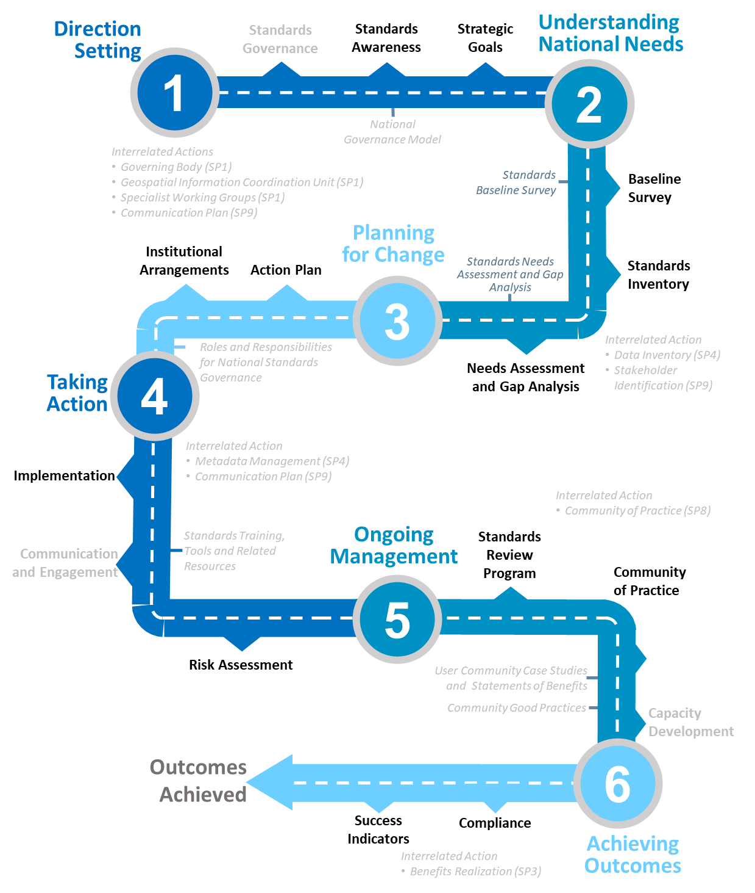

*Figure I.1. Actions and tools designed to assist countries to establish good practice standards and compliance mechanisms (*Adapted from IGIF SP6)*.*

Furthermore, use cases (case studies), an integral part of this Guide, are introduced in each section of the document, with an expanded list of case studies also provided as an [Appendix](https://docs.google.com/spreadsheets/d/1fr_qnz47EsDbHyaZatwdHS940QBm4b9nXT7erVg1-nk/edit?usp=sharing). Specific guidance and options are provided for those who want to implement standards adoption and compliance as part of an IGIF.

Even though the IGIF SP6 aims to guide country-specific action plans for standards adoption and compliance in the context of national geospatial information management, this Guide is also useful for other organizations, such as state and provincial governments, private sector, and non-profit organizations. This Guide will help them to understand how their data, services and systems can be seamlessly integrated with national geospatial information and how their products and offerings can achieve the necessary flexibility to innovate and rapidly mobilize new technologies and data sources.

The target audience for this Guide comprises four groups representing the different roles they play in standardization. Each of the groups can be linked to one of the four Elements of Standards in the IGIF/SP6, illustrated in Table I.2. This Guide was prepared with the aim to be understandable by those who are relatively new to the topic of geospatial standards, as well as those proficient in the use of standards. At the same time, this Guide provides guidance to both high-level policy and decision-makers, as well as implementers of standards.

|  |  |  |  |  |
| --- | --- | --- | --- | --- |
| **Roles** | **Link to IGIF/SP6 Element** | **Required level of understanding standards** | **Activities** | **Relation to this Standards Guide** |
| Decision makers | Governance and Policy | Can recognize the benefits of standards, in reaching long-term goals | - Set government policy framework  - Allocate funding | Secondary target audience |
| Developers  of interoperable solutions | Technology and  Data Interoperability | Can implement standards,  Can develop & revise standards | - Ensure design meets national needs and challenges  - Participate in standards development | Main target audience |
| Standards users | Compliance Testing and Certification | Can interpret & use standards | - Participate by expressing needs  - Implement internal policy to align with endorsed standards | Target audience |
| Practitioners in the public and private sector, and civil society | Community of Practice (CoP) | Can discover & use standards as good practice | - Identify needs for standards contributing to the Sustainable Development Goals (SDGs)  - Participate in standards development, adoption, and implementation | Target audience |

*Table I.2. The four groups of the target audience for this Guide and their relation to the IGIF SP6 Elements of Standards.*

**Decision makers** are responsible for the governance framework and policy environment that support standards adoption and compliance. They also provide the resources and allocate funding. Decision makers therefore want to understand how the benefits of standards adoption and compliance can be maximized to achieve their strategic goals. This Guide provides examples from a number of countries, information communities or organizations; guidance on how to develop a common framework of national data and technology standards; and guidance on how national requirements can be represented and addressed in the activities of international Standards Development Organizations (SDO). Decision makers can use these examples to guide action plans for achieving optimal outcomes and benefits. After reading the respective section in the Guide, a decision maker will be able to:

* Direction setting: Understand the benefits of standards and the importance of setting strategic goals to achieve increasing levels of geospatial maturity.
* Understanding needs: Understand which standards are available to assess and address an organization’s needs based on geospatial maturity level or tier.
* Planning for change: Understand how other nations or organizations have implemented and used standards to meet their needs.
* Taking action: Understand the level of maturity of the nation and/or organization and thereby the level of complexity and the potential work that needs to be done during the implementation phase.
* Ongoing management: Authorize and resource a standards maintenance process essential for maintaining an effective national geospatial information management and sharing environment.
* Achieving outcomes: Understand the importance of how standards will improve sharing and use of geospatial information and optimize geospatial information management

**Developers of interoperable solutions** are the primary target audience for this Guide. They develop and implement technologies so that different systems and diverse data types can work together seamlessly. They may also be involved in the development of standards or profiles that meet the specific needs of their countries or organizations. This Guide provides them with information about the different types of standards, how they facilitate interoperability, how to access standards and how they have been implemented in other countries, information communities and organizations. Developers of interoperable solutions can use this Guide to plan and design their own implementation or development of standards to ensure that they meet the needs and address the challenges of their countries or organizations. After reading the respective section in this Guide, a developer of interoperability will be able to:

* Direction setting: Identify the types of standards required for increasing levels of capability and scale of collaboration and understand the role of SDOs and how to participate in standards development.
* Understanding needs: Understand which standards are available to assess and address an organization’s needs based on geospatial maturity level or tier, and understand how standards are evolving along with changing needs and technologies.
* Planning for change: Understand the importance of considering and implementing standards as part of the systems development lifecycle, and the importance of contributing to and providing feedback to the development of standards through direct participation and provision of feedback.
* Taking action: Understand details about what standards are needed and applicable in different cases, how to access the standards, and how to take the essential steps to implement those standards.
* Ongoing management: Understand how to remain current with advancements in standards through periodic review with standards bodies and communities of practice.
* Achieving outcomes: Understand use cases to apply rapid mobilization of new sources of data and technologies and avoid lock-in to specific technology providers.

**Standards users** evaluate and select standards or standards-based products for implementation in their countries or organizations, with the goal of achieving national or organizational goals. They need to understand how a standard achieves interoperability and whether a standards-based product complies and/or is certified to comply with a standard. They want to know the standardization target for a specific standard (e.g., web service or metadata) and the kind of interoperability that can be achieved (e.g., system, structural, syntactic, or semantic). This Guide provides them with information about the different types of standards, how they facilitate interoperability and how compliance to standards is tested and certified. The Guide helps to inform the evaluation approach followed by a standards user to make sure that selected standards or standards-based products meet the needs and address the challenges of their countries, organizations, or information communities. Each section provides standards users with specific insight into an effective implementation strategy:

* Direction Setting: Understand the different types of standards and how they contribute to interoperability and generate benefits.
* Understanding Needs: Understand which standards are available to assess and address an organization’s needs based on geospatial maturity level or tier, and understanding how standards are evolving along with changing needs and technologies.
* Planning for change: Understand the types of business needs that may be supported through the implementation of standards, advocating for the adoption of standards to facilitate interoperability and other efficiencies, and understand the importance of considering and implementing standards as part of the systems development lifecycle, and the importance of contributing to and providing feedback to the development of standards through direct participation and provision of feedback.
* Taking action: Match the standards required to fulfill their needs to a given maturity level.
* Ongoing management: Discuss, identify, and submit requirements for standards to address interoperability issues through standards bodies at the organizational, national, and international levels.
* Achieving outcomes: Understand requirements for improved uptake of geospatial information across government and with the private sector and citizens; and creating efficiencies in geospatial data production and lifecycle management; saving effort, time, and cost in reusing and repurposing data.

**Practitioners** in the public and private sector and civil society are often represented in different communities of practice**,** groups of people with a shared interest in standards who actively participate in the development, adoption, implementation and/or use of standards. A community realizes the benefits of standards and interoperability by sharing and leveraging proven standards-based good practices and training material specific to their community’s needs. A Community of Practice (CoP) can also provide commonality across diverse uses and levels of operation, and help promote consistent, sharable training and educational programs. This Guide provides communities of practice with an overview of standards and standardization and suggests domain and technology trends expected to be standardized in the future. CoPs can use this Guide to inform and plan contributions to standards development, adoption and implementation of standards, and development of training material and educational programs. It can also serve to identify a community’s standardization needs that are not yet addressed. After reading the respective section in this Guide, members of a CoP will be able to:

* Direction setting: Understand the different types of standards and how they contribute to interoperability and generate benefits.
* Understanding needs: Understand which standards are available to assess and address an organization’s needs based on geospatial maturity level or tier.
* Planning for change: Understand how they can play a role in the identification of opportunities for standardization in the context of their domain, act as advocates to engage related communities of practice to facilitate alignment and interoperability at various levels.
* Taking action: Understand the standards and provide feedback into the ongoing development of the implemented standards.
* Ongoing management: Understand how they can share experiences and standards success stories with others.
* Achieving outcomes: Understand the benefit realization and compliance of standards with the development of indicators to assess, monitor and evaluate as part of an internal/external auditing exercise.

# **Direction Setting**

|  |
| --- |
| The purpose of this section is enabling the reader to:   * Understand the benefits of standards and the importance of setting strategic goals to achieve increasing levels of geospatial maturity. * Identify the types of standards required for increasing levels of capability and scale of collaboration. * Understand the role of standards development organizations (SDOs) and how to participate in standards development. * Understand the different types of standards and how they contribute to interoperability, and examples of benefits. |

## **Standards Awareness**

When undertaking a leadership role on geospatial standards, it is important to understand the practical use of standards and to raise awareness of the benefits of moving towards a standards-based approach for geospatial data management at all levels of government, the private sector and academia.[1] When it comes to the implementation of standards, benefits include:

* Reducing cost over the lifecycle of a system or systems.
* Ensuring the ability to share data when appropriate, with respect for privacy issues.
* Enabling interoperability among systems.
* Enabling interoperable sharing and operations.
* Enabling innovation by facilitating rapid mobilization of new technologies and data sources.
* Supporting disconnected or local operations.

*Interoperability* is the ability to access, exchange, integrate and cooperatively use data in a coordinated manner, within and across organizational, regional, and national boundaries.[2] As described in IGIF SP6, technology and data interoperability enables different technologies, systems, and geospatial data to work together seamlessly, and provides the flexibility to rapidly mobilize newer technologies and data sources.

### **What are Standards and Why are They Important?**

A standard is a documented agreement between provider and consumers, established by consensus, that provides rules, guidelines, or characteristics ensuring materials, products, and services are fit for purpose. Behind the scenes, standards make everyday life work. They may establish size or shape or capacity of a product, process, or system. They can specify performance of products or personnel. They can also define terms so that there is no misunderstanding among those using the standard.

### **Standards Save Time, Money, and Lives**

In 1904, much of the City of Baltimore in the United States was destroyed by a massive fire. Firefighters from hundreds of kilometers away were sent to assist Baltimore firefighters during the height of the blaze. They could do little to help because the fire hose size and threads used by different responders were not standardized for compatibility with Baltimore fire hydrants[3]. The resultant inability to connect hoses to fire hydrants turned hundreds of firefighters into spectators. This analogy rings true not just in respect of the need to share geospatial information, such as disaster imagery, during a crisis but throughout all implementations of geospatial technologies. Standards make uniformity, compatibility, and interoperability possible for electronic devices, software applications, and processes in all sectors of a global economy.



*Figure 1.1: Aftermath of the 1904 Great Baltimore Fire (source: Wikipedia)*

Without standards, the ability to connect systems, data, people, hardware, software, and procedures becomes difficult and inefficient. Loss of time, assets and lives is inevitable.

A recent example of the value of standards was brought to the surface by the COVID-19 pandemic. Addresses provide one of the most common and unambiguous ways to identify and locate objects, and assist services such as postal delivery, emergency response, marketing, mapping, utility planning and land administration. Addresses and address data turned out to be crucial in the fight against COVID-19 because they enabled contact tracing and identification of cluster outbreaks. Non-standardized addresses significantly hinder the response to COVID-19. The multi-part International Organization for Standardization (ISO) 19160 Addressing Standard supports a variety of stakeholders so that accurate and reliable address data can be made available. The different parts of ISO 19160 cover topics such as terminology and a conceptual data model for addressing; good practices for address assignment and maintenance; quality of address data; and international postal addressing (jointly developed with the Universal Postal Union).

### **The Case for Open Standards**

Open standards facilitate interoperability and data exchange among different products or services intended for widespread adoption. Standards and specifications define requirements to ensure that products and data are consistent in accuracy, structure, format, style, and content.[4] Standards development is a process that requires consensus among stakeholders. Open standards are a central element in the growing trend towards effective government.

**Open international standards** are voluntary consensus-driven standards published by the SDOs. Open standards[5] are developed, approved, and maintained via a collaborative and consensus-driven process and made available to the general public. These standards are aimed at achieving legal, data, semantic and/or technical interoperability. Furthermore, open standards offer users the opportunity to have a voice in building and learning about the standards. Apart from standards, the SDOs offer other types of open documents and services, such as specifications and reports, to respond to urgent market needs or to address work still under technical development.

The main focus of the IGIF SP6 and this Guide is on open international geospatial standards. However, other means of information sharing that may lead to or supplement standards are also described in this subsection:

**Specifications** generally offer an interoperability solution similar to that of standards, but are not necessarily developed in the same voluntary, consensus-based process. Specifications may precede or contribute to the body of knowledge for new open standards, thus serving a meaningful role in furthering innovation in the geospatial industry.[6] In the case of the OGC, output from the OGC Innovation Program initiatives may result in draft specifications for consideration for development as a standard. Further, open standards or specifications developed externally to the OGC may submitted to the OGC to become formally endorsed as OGC **community standards**.[7]

Based on international standards, **profiles** may be established and endorsed by governance bodies to meet the specific needs of their country or organization. Metadata profiles, such as the [*INSPIRE dataset and service metadata*](https://inspire.ec.europa.eu/id/document/tg/metadata-iso19139)*,* and the [Latin *American Metadata Profile LAMP version 2 (LAMPv2)*](https://committee.iso.org/sites/tc211/home/standards-in-action/user-story-challenge/paigh---latin-american-metadata.html) are examples of profiles based on international standards.

**Good practices** describe how an open standard is applied against scenarios or define a profile that tailors it to the requirements of a specific community. Good practices (also referred to as best or proven practices) often highlight the practical use of one or more standards and specifications or address particular use cases. They may relate to implementing tools and techniques, emerging technologies and standards, or extensions/profiles for specific application domains.[8]

Over time and with broad adoption, a specification may be so widely used that the community considers it a **de facto standard** for a given application, even if it was not assigned an official status by a governance body. Developers should be aware that some de facto standards require proprietary solutions to be licensed in order to implement them. De facto standards should balance interoperability, access, and use requirements and be used in parallel with open international or national standards when possible.[9]

Closed standards or specifications carry risks that may pose hidden challenges such as delays and costs of expanding or adapting data and software tools to work with other resources, software, or organizations. Organizations should be aware of the potential risk to interoperability of closed standards or specifications and consider these risks on balance with the benefits. Open standards and specifications, on the other hand, help organizations best balance their needs while minimizing business and technology risks.

In an ever-changing world, open standards help assure that organizations can more quickly take advantage of new geospatial information sources and new technology tools. International standards developed and maintained by the consensus processes of recognized SDOs help avoid risk by broadly addressing and managing community requirements for interoperability, access, and use.

### **The Benefits of Open Geospatial Standards**

Geospatial information, technologies, and standards help enable and improve the sharing, integration, and application of geospatial information for decision making. While national governments can make proactive policy choices to maximize benefits, other jurisdictions and enterprises must align with this policy to achieve mutually optimal outcomes.

A multi-national response to a regional disaster is one example where having clear policy on the sharing of geospatial information is critically important. The shaping of appropriate geospatial policy is beyond the mandate of this Guide (See [IGIF SP2](http://ggim.un.org/IGIF/part2.cshtml)), but it must be addressed. For without a suitable policy framework the standards-based approaches described in this Guide will be of limited value.

The remainder of this Guide seeks to answer the following questions directly related to the role of standards in geospatial information management:

* What are the common standards adopted by organizations worldwide?
* Which of these standards are appropriate for geospatial information management in the context of the UN initiative on Global Geospatial Information Management?
* What are the appropriate geospatial standards for an organization’s needs?

In addition to these questions the overall value proposition associated with open standards should be considered by all stakeholders. The fundamental questions include quantifying the benefits, examining the reduction of related risks, as well as the potential for improved productivity and new opportunities.

### **Examples of Quantitative Benefits**

Open standards facilitate increased return on geospatial investment through a host of mechanisms. Return on investment may be realized through direct means such as improved efficiency, from saved time and effort, or through the ability to rapidly mobilize new capabilities. The following examples demonstrate the monetary benefits of standardization:

* The German Institute for Standardization (DIN) estimated benefits of 17 billion euros to the German economy in 2010: “Standards promote worldwide trade, encouraging rationalization, quality assurance and environmental protection, as well as improving security and communication. Standards have a greater effect on economic growth than patents or licenses.”[10]
* The Joint Research Centre of the European Union collaborated with the Universitat Politècnica de Catalunya (Spain) in concluding that the establishment of the Spatial Data Infrastructure (SDI) of Catalonia -- based on open geospatial standards -- generated significant internal efficiency benefits as well as benefits of more effective service delivery. They quantified these benefits and estimated that the value exceeded four year’s investment in just over six months.[11]
* Of the projects considered in a NASA Geospatial Interoperability Return on Investment Study, the project that adopted and implemented geospatial interoperability standards had a risk-adjusted ROI of 119.0%. This ROI is a “Savings to Investment” ratio. This can be interpreted as for every $1.00 spent on investment, $1.19 is saved on Operations and Maintenance costs. Overall, the project that adopted and implemented geospatial interoperability standards saved 26.2% compared to the project that relied upon a proprietary standard. One way to interpret this result is that for every $4.00 spent on projects based on proprietary platforms, the same value could be achieved with $3.00 if the project were based on open standards.[12]
* New Zealand SDI Benefits: Spatial Information in the New Zealand Economy - Realizing Productivity Gains is a report commissioned by Land Information New Zealand, the Department of Conservation, and the Ministry of Economic Development. It provides robust economic analysis that quantifies the contribution spatial information makes to the New Zealand economy, as well as opportunities for this contribution to grow. The report concludes that use and re-use of spatial information is estimated to have added $1.2 billion in productivity related benefits to the New Zealand economy in 2008.[13]
* The Global Geospatial Industry Outlook (2019), published by Geospatial Media and Communications, valued the global geospatial industry at an estimated US$ 339.0 billion in 2018. The cumulative geospatial industry is projected to reach US$ 439.2 billion by 2020, growing at a compound annual growth rate of 13.8%. This growth acceleration can be accredited to continuous technology advancements in the industry, democratization of geospatial information riding on integration with advancements in digital technologies and resultant innovative business models. Adopting open standards is considered to be important for the way forward and for realizing the full potential of geospatial technologies.
* In 2019, the Singapore government announced a Marine Spatial Data Infrastructure (MSDI) called “[GeoSpace-Sea](https://ihr.iho.int/articles/singapores-national-marine-spatial-data-infrastructure-geospace-sea-enabling-hydrospatial-context/)”. Focused on data harmonization and interoperability standards, GeoSpace-Sea is designed to bridge the land/sea information gap and enable interdisciplinary marine coastal applications for the Singapore government. The establishment of a national MSDI will help provide environmental, social, and economic benefits to Singapore.  For instance, the maritime industry, which contributes 7% of Singapore’s Gross Domestic Product (GDP), and the aquaculture industry will benefit from GeoSpace-Sea through increased efficiency, safety, and sustainability.

**Key Types of Geospatial Standards**

There are several different ways in which standards for geographic information can be categorized or characterized. The IGIF SP 6 refers to three general types of standards:

* Domain-specific standards
* General-purpose standards for geospatial information and technology specifically
* General-purpose standards for information technologies and the internet generally.

Examples of standards for each of these types are found in Sections 2 and 4 of this Guide.

Some standards serve as general-purpose IT standards. For example, the [*Unified Modeling Language (UML)*](http://www.uml.org/)*,* developed and published by the Object Management Group (OMG) and ISO/IEC JTC 1, can be used for “specifying, visualizing, constructing, and documenting the artifacts of software systems, and for business modeling”. It is not specific to geospatial information and technologies. [*ISO 19103, Geographic information -- Conceptual schema language*](https://www.iso.org/standard/56734.html), is a profile[14] of UML for the special case of describing geographic information. It is not specific to any domain or context and therefore also has a general purpose in the context of geospatial information and technologies. The general-purpose standards are also referred to as “foundational” standardsbecause they form the technological basis for geospatial information exchange (see Figure 1.2).

Other standards describe geographic information related to a specific domain or context. Standards, such as the Open Geospatial Consortium (OGC) [*Groundwater Markup Language (GroundwaterML)*](http://www.ogc.org/standards/gwml2)*,* [*ISO 19160-1 Addressing -- Part 1: Conceptual model*](http://www.iso.org/standard/61710.html), and [*ISO 19152 Geographic information - Land Administration Domain Model (LADM)*](http://www.iso.org/standard/51206.html) make use of the general-purpose [*ISO 19103 Geographic information -- Conceptual schema language*](http://www.iso.org/standard/56734.html) to describe geographic information related to ground water, addressing and land administration respectively.

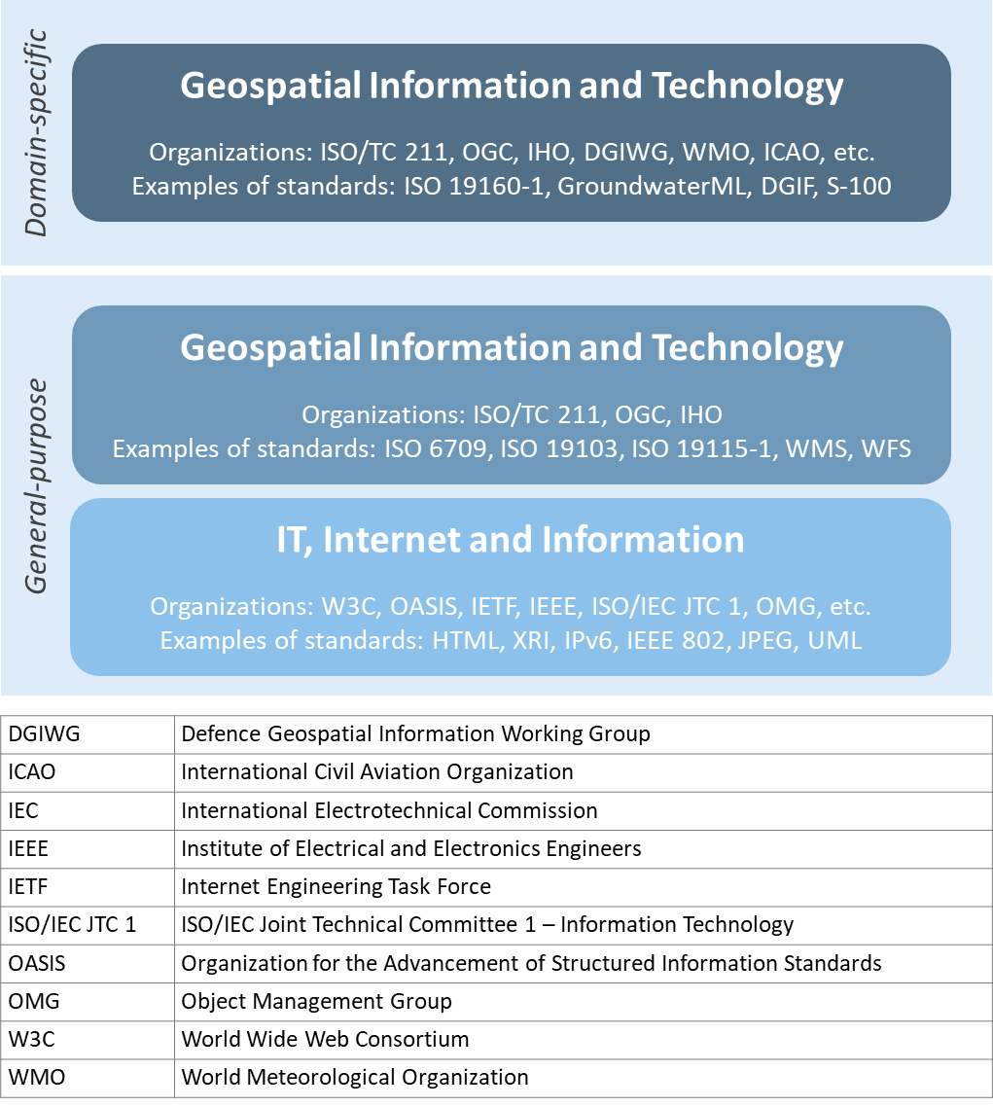

**Figure 1.2:** *Characterization of general-purpose IT and geospatial standards, and domain-specific geospatial standards.*

Geospatial standards can be further characterized based on one of three standardization targets[15]:

1. Information (or content) standards
2. Service or interface standards
3. Procedural standards.

A specific standard is not necessarily aimed at a single standardization target. Sometimes information, services and procedures are grouped into a single standard for a specific domain. For example, [*ISO 19147, Geographic information -- Transfer Nodes*](http://www.iso.org/standard/54759.html) defines both transfer node information relevant for travel planning and modelling of interoperable transport systems, as well as a set of services related to transfer nodes.

Therefore, these characterizations are important when deciding which standard to use and are described in more detail below:

**Information** **standards** address heterogeneity at the semantic, structural, and syntactic level, i.e., they standardize the meaning of information (e.g., by defining concepts), how it is structured (e.g., through a conceptual model) and how it is encoded (e.g., a standardized digital encoding). Examples include [*OGC GroundwaterML*](http://www.ogc.org/standards/gwml2)*,* [*ISO 19115-1, Geographic information -- Metadata -- Part 1*](http://www.iso.org/standard/53798.html)*: Fundamentals* and [*ISO 19160-1, Addressing -- Part 1: Conceptual model*](http://www.iso.org/standard/61710.html).

**Service or interface** **standards** define the rules for interacting with services and components in order to discover, access or process geographic information. Examples include the [*OGC Web Mapping Service (WMS)*](http://www.ogc.org/standards/wms) *(also* [*ISO 19128*](http://www.iso.org/standard/32546.html)*)*, [*OGC Web Feature Service (WFS)*](http://www.ogc.org/standards/wfs) (also [ISO 19142](http://www.iso.org/standard/42136.html)) and [*ISO 19132, Geographic information - Location-based services - Reference mode*](http://www.iso.org/standard/40601.html)*l*. Ideally, when standards are implemented in products or online services the resulting components work together seamlessly.

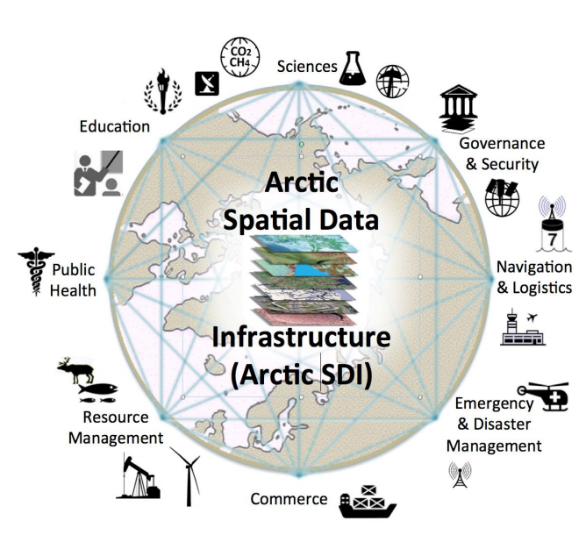

The Arctic Spatial Data Infrastructure employs OGC / ISO geospatial standards to enable access to arctic information from contributing nations.

www.arctic-sdi.org

*Figure 1.3: International cooperation on Arctic issues through OGC / ISO standards-based SDI and Portal*

**Procedural standards** describe an ordered series of steps to accomplish a specific task. Examples include [*ISO/TS 19158, Geographic information - Quality assurance of data supply*](http://www.iso.org/standard/32576.html), and [*ISO 19135-1 Geographic Information - Procedures for item registration - Part 1: Fundamentals*](http://www.iso.org/standard/54721.html). Together, these standards allow different systems and applications to communicate and work together.

When selecting **Interoperability standards**, one needs to know which kind of interoperability[16] can be achieved by its implementation.

* **System interoperability** is achieved if hardware, operating systems, and communication systems are able to communicate and work together, e.g. by standards such as[*IETF IPv6*](http://tools.ietf.org/html/rfc2460) and [*IEEE 802*](http://www.ieee802.org).
* **Syntactic interoperability** is achieved if different systems, applications, or services can exchange information via a common encoding, such as [*GeoJSON*](http://tools.ietf.org/html/rfc7946) or the shapefile format.
* **Structural interoperability** is achieved if systems, applications, or services can exchange information through a common conceptual model or the mapping from one model to another. This addresses heterogeneity in structure, e.g., a street can be represented as an object of the type ‘Street’ or by a generic geospatial object whose attribute (or tag or property) has the value ‘street’.
* **Semantic interoperability** is achieved when the differences in language, cultural and domain meanings between concepts and data representing reality are eliminated. These differences arise from the various perspectives and contexts from which real-world phenomena are abstracted. Between organizations, and even within the same organization, the terminology for a particular phenomenon may have many meanings and contexts. For example, depending on the context, a “bridge” can be an element of a road infrastructure, a platform of a ship, an obstacle in marine navigation, or a point of interest for tourists. Another example, a ‘tower’ can be a communication facility, a navigation landmark, and an aeronautical obstacle.

***Semantics***, in the context of this Guide, refers to the meaning of words, terms and concepts related to geospatial information. Semantic interoperability is an important part of standardization at national, international, and local levels. For information to flow among jurisdictions and organizations, it is essential that all parties agree on the meaning or intent of what the information represents. Through the semantic mediation process, national data can be combined with common meanings to address regional topics that transcend national boundaries.

### **How are Standards Implemented?**

Depending on how they are used, standards can be grouped into meta and application (or instance) level standards:

* **Meta level** standards will typically not be implemented at the country level yet are required for the development of other standards. It is important to know that these standards exist and understand their role in standardization. Examples include[*ISO 19104, Geographic information -- Terminology*](http://www.iso.org/standard/63541.html), and [*ISO 19105, Geographic information -- Conformance and testing*](http://www.iso.org/standard/26010.html),
* **Application level** standards are directly implementable, such as metadata standards (e.g.,[*ISO 19115-1*](http://www.iso.org/standard/53798.html)), ontologies for a specific domain or implementation (e.g., [*OGC WaterML*](http://www.ogc.org/standards/waterml) or [*ISO 19160-1, Addressing - Part 1: Conceptual model*](http://www.iso.org/standard/61710.html)) or service specifications (e.g. [*OGC WMS*](http://www.ogc.org/standards/wms) and [*OGC WFS*](http://www.ogc.org/standards/wfs)). Countries often develop their own profiles (specializations) of international application-level standards (e.g., the [Infrastructure for Spatial Information in the European Community (INSPIRE) Metadata](http://inspire.ec.europa.eu/metadata/6541)),

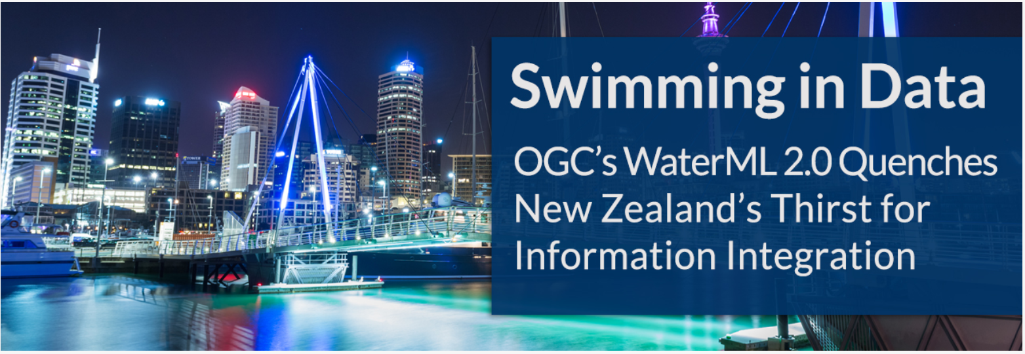

*Figure: 1.4: Using OGC WaterML and OGC/ISO application-level web services standards, New Zealand created an integrated national water resource system from 16 separate regional catchment authorities. www.ogc.org/blog/3285*

* **Instance level**standards refer to the implementations of standardized data, services, or procedures. Examples would be the standardized geospatial datasets that are made available as part of a national SDI.

### **SDOs for Geospatial Information**

The majority of international standards are developed in SDOs that use a consensus process guided by documented, repeatable and well proven policies and procedures. This helps ensure that the standards developed meet the needs of all users.

The three international organizations that participated in the development of this document share the objective of developing standards for geospatial information:

* The ISO Technical Committee 211 Geographic information/Geomatics ([ISO TC/211](https://www.iso.org/committee/54904.html))
* The Open Geospatial Consortium ([OGC](https://iho.int/))
* The International Hydrographic Organization ([IHO](https://iho.int/)).

Additionally, the World Wide Web Consortium ([W3C](https://www.w3.org/)) and Internet Engineering Task Force ([IETF](https://www.ietf.org/)) are examples of two SDOs that develop foundational standards which are increasingly important in contemporary geospatial applications based upon internet and web technologies. Amongst others, the American Society for Photogrammetry ([ASPRS](http://www.asprs.org)) and the Geospatial and Remote Sensing Society ([GRSS](http://www.grss-ieee.org)) of the Institute of Electrical and Electronic Engineers also play roles in geospatial standards development.

These international standards organizations have representative members from government, industry, research, non-government organizations and academia who arrive at decisions through a consensual process. The organizations develop, maintain, and make publicly available open standards that facilitate the ability to publish, discover, access, manage and use geospatial information across a range of applications, systems, and business enterprises.

### **The Benefits of Joining an SDO**

To take advantage of emerging standards and trends, countries and organizations can leverage the global resources of groups such as the UN-GGIM, SDOs, and other major associations mentioned in this document to identify trends and to adopt good practices.

Organizations participate in standards development work of OGC, ISO/TC 211 and IHO to understand implications and assure earliest implementation of standards that will help ease integration of new technologies and data sources. Manyfold benefits can be achieved by formally joining or informally participating in an SDO. These benefits include:

* Access to communities of experts to gain and share knowledge.
* The ability to influence the development of international standards.
* Opportunity to access and contribute to innovative new technologies, with potential funding programs.
* Gaining insight into emerging new technology trends and how standards emerge around them.
* Trusted advice - regulators can rely on standards as a solid base on which to create public policy.
* Forging international partnerships for government and academia.
* Building capacity via formal training and development programs.
* Contributing to the UN Sustainable Development Goals.

At a minimum, organizations and institutions should consider providing their interoperability requirements to the OGC, ISO, and/or IHO. This does not require much time but ensures that these requirements are documented and considered in the ongoing development of international standards.

The Open Geospatial Consortium (OGC) is an international consortium of geospatial experts from more than 500 businesses, government agencies, research organizations, and universities driven to make geospatial (location) information and services FAIR - Findable, Accessible, Interoperable, and Reusable. OGC's member-driven consensus process creates [royalty free, freely available, open geospatial standards](https://www.ogc.org/docs/is). OGC actively analyzes and anticipates emerging [tech trends](https://www.ogc.org/ogctechtrends), and runs an agile, collaborative Research and Development (R&D) lab - the [OGC Innovation Program](https://www.ogc.org/ogc/programs/ip) - that builds, tests and prototypes candidate standards to address community challenges. Membership details and benefits can be found at <https://www.ogc.org/ogc/benefits>

The [ISO](http://www.iso.org/committee/54904.html) is a global network of national standards bodies. Members are the foremost standards organizations in their countries and there is only one member per country. Each member represents ISO in its country. Individuals or companies cannot become ISO members, but there are ways that you can [take part in standardization work](https://www.iso.org/get-involved.html), either through a national standards body (the member), or by becoming a liaison organization to an ISO committee, in the case of geographic information, this is ISO TC/211. Specific details can be found at <https://committee.iso.org/home/tc211>

The [IHO](https://iho.int/en/become-a-member-state) is the inter-governmental technical and consultative organization that sets global standards for hydrography and nautical charting and provides global coordination and support for the world’s national hydrographic services. It is a recurring recommendation of the General Assembly of the UN and of the International Maritime Organization (IMO), that every coastal State should be a member of the IHO in order to meet its international obligations while maximizing the national economic benefits that accrue from a comprehensive national hydrographic program. More details can be found at <https://iho.int/en/become-a-member-state>

The [W3C](http://www.w3.org) is an international community where Member organizations, a full-time [staff](https://www.w3.org/People/), and the public work together to develop Web standards. More details can be found at <https://www.w3.org/>

For further information on how to become a member or participate with these organizations please see their respective websites.

## **Emerging Standards and Trends**

Standards continuously adapt to changes in technologies and other developments. On a regular basis, the UN-GGIM reviews and publishes [a five to ten year vision on future trends in geospatial information management](https://ggim.un.org/meetings/GGIM-committee/10th-Session/documents/Future_Trends_Report_THIRD_EDITION_digital_accessible.pdf). In the most recent version, the top five geospatial industry drivers predicted to have the greatest impact on geospatial information management over the next 5 to 10 years were identified: the rise of new data sources & analytical methods; technological advancements; evolution of user requirements; industry structural shift; and legislative environment. More specifically related to standardization, the Trends provide a forecast of technologies and related geospatial standardization requirements. Amongst others, a mind map of emerging trends, grouping and road map of synergetic trends and a summary chart of Priority Tech Trends are reviewed and published regularly. These documents should be read in the more general context of the importance of geospatial information management to international [Sustainable Development Goals (SDGs)](http://sdgs.un.org/goals), as discussed in Monitoring Sustainable Development Contribution of Geospatial Information to the Rio+20 process.

The market is delivering technology advancements on a continual basis. Many of these advancements will help to further improve organizational decision making and reduce cost and effort associated with IT infrastructure. Organizational leadership must be prepared to take advantage of key technology advancements when they become widely available.

## **Strategy for Standards Implementation**

### **Tiers: A Goal-based Approach to Implementation**

Organizations, institutions, and information communities are likely to be starting their standards journey at different points in the capability/maturity continuum, requiring a phased implementation approach that considers the different levels of experience and expertise of the people involved.[17] Collaborative initiatives to share and deliver geospatial information are typically oriented around SDI initiatives.

Standards for geospatial information can be seen as a continuum, enabling the achievement of increasing levels of interoperability of geospatial information as more standards are adopted and adapted to keep pace with evolving requirements, technologies, and tools.

Reaping the benefits of standards adoption is a journey and organizations, institutions and information communities are likely to be starting this journey at different points in the capability/maturity continuum. This guide provides a model for the phased implementation of geospatial standards that considers the different levels of experience and expertise of the players involved. Some organizations and institutions are far advanced, others are just beginning, and some are only considering the use of standards. Figure 1.5 describes several “Tiers” that convey a standardization trajectory where the levels of capability and scale of collaboration increase as knowledge and experience are gained.

Standards are a critical element of geospatial information management. In Figure 1.5, the trajectory for increasing levels of capability and collaboration is shown over four Tiers:

* **Tier 1** - Share maps internally and over the Web.
* **Tier 2** - Geospatial Information partnerships to share, integrate and use geospatial data from different providers.
* **Tier 3** - Spatially enabling the nation, large scale (typically national) efforts to develop a comprehensive SDI that provides access to multiple themes of information, applications for using the shared information, and access via a variety of environments (mobile, desktop, etc.).
* 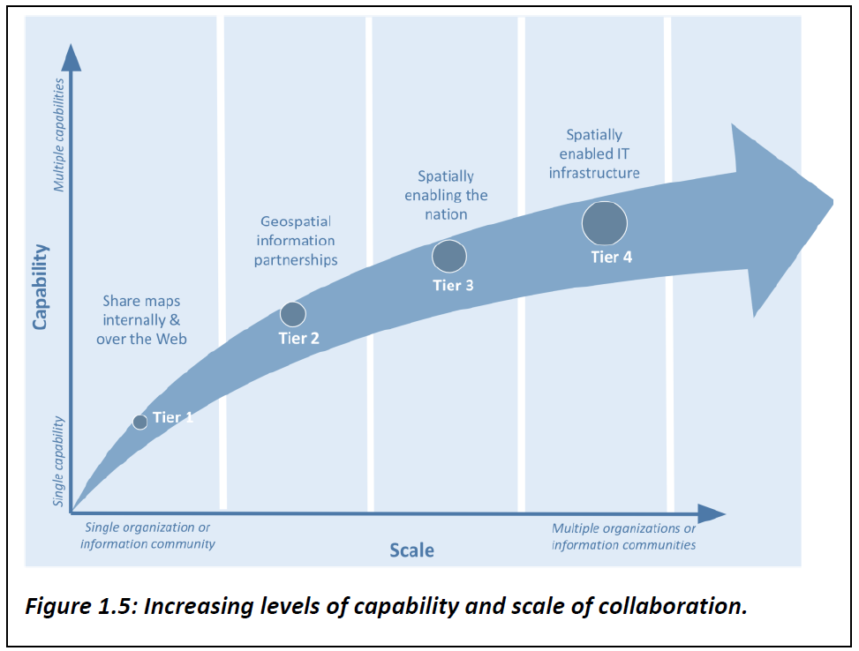**Tier 4** - Towards spatially enabled IT infrastructure, delivering geospatial information into the Web of data, and bridging between SDI and a broader ecosystem of information technology systems.

*Figure 1.5 Increasing levels of capability and scale of collaboration*

Decades of experience has shown that lack of consensus, leadership commitment, and a clear governance structure are the key factors limiting the full achievement of the benefits of open standards. Constrained funding, inadequate governance arrangements, a lack of understanding of the value proposition of using a standards-based approach and a lack of knowledge and experience in standards implementation are major limiting factors and are often related to a lack of consensus among stakeholders. With communication between stakeholders comes an exchange of knowledge and experience.

As consensus builds, understanding improves and the willingness of stakeholders to commit resources and coordinate activities in an open fashion grows. This facilitates a continuing, self-sustainable, and self- governed expansion of open standards. Single agency portrayal of basic information develops into collaborative multi-agency standards implementation that takes fuller advantage of emerging technological developments. Recognizing the complexity and constraints, it can be worthwhile to implement standards in an incremental fashion. Full interoperability can take time as an organization or institution matures in both technical and policy terms.

### **Standards Adoption with Increased Maturity**

As the need for interoperability increases, more standards are adopted with increased maturity. Increased capability and scale of collaboration are associated with sets of standards being adopted, as shown in Figure 1.6.

The Tiers represent a series of steps in an organization’s ability to offer increasing levels of geospatial information and associated services as part of an information community. At the beginning of the process (Tier 1), an organization may want to provide access to geospatial information delivered as map images together with a description of them (i.e., metadata).

*Figure 1.6: Standards adoption over increased capability and scale of collaboration*.

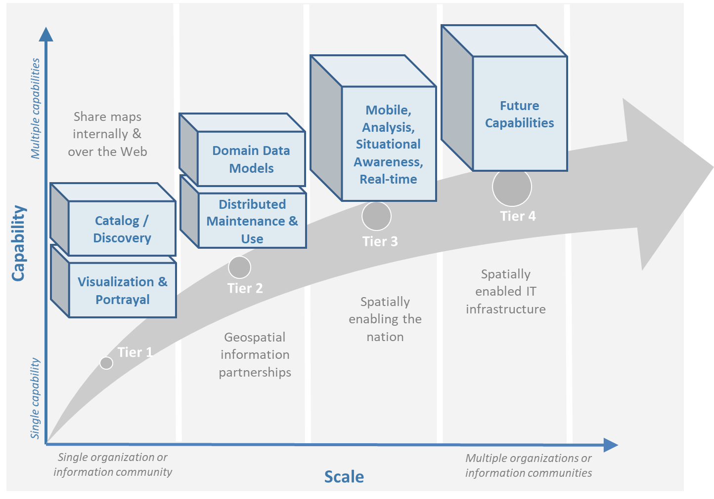As an initiative matures, multiple organizations may wish to collaborate to provide a means to share, search, access, integrate and cooperatively maintain and use a particular geospatial information layer (such as transportation) from multiple sources using web services (Tier 2).

Larger scale initiatives have a goal of establishing a nation-wide coverage of foundation or framework[18] data as part of their National SDI (NSDI). Foundation data is an accurate set of key geospatial data layers needed most by different users (imagery, elevation, administrative boundaries, transportation, land use, and water features for example). Providing access to this geospatial Foundation Data for a range of application areas is the next level of maturity (Tier 3).

Finally, to address emerging needs and leverage new technologies and opportunities such as crowdsourcing of geospatial information and big data analytics, a community would focus on delivering geospatial information from SDI environments to spatially enable the broader IT infrastructure (Tier 4).

The scale and scope of an initiative in terms of the number of stakeholders and the number of information communities are also presented in this diagram. At each Tier, as more stakeholders adopt standards, the scale of the initiative increases. Likewise, as initiatives move along the continuum from one Tier to the next, from single organization to information communities, the scale of interoperability grows, and the value proposition of standards adoption pays dividends.

The description of the Tiers provided later in this document identifies the specific suites of SDI standards that are used to achieve them, in the form of blocks that are stacked on top of each other. An [Inventory of Standards (Appendix 1)](https://drive.google.com/file/d/1DAb4QinqlEecqFzvtqi7JpnX7zzpdZJM/view?usp=sharing) provides details on the specific suite of standards associated with each Tier.

### **Mechanisms for Facilitating Technology and Data Interoperability**

***Feature catalogues*** are a common mechanism for enforcing semantic interoperability in geospatial information. Feature catalogues[19] describe the semantics of what is meant by ‘Tower’, so all consumers of the information agree, and what properties of the feature are important to describe it, such as height above ground, height above sea level, construction, or navigational marks (e.g., lights). The feature catalogue contains a record of all the features that are relevant within the organization or jurisdiction. The agreed understanding of what is relevant is known as the universe of discourse.

***Ontologies*** ***and conceptual models*** are a means to describe a universe of discourse by describing and categorizing concepts, their properties, and relationships between them. Conceptual models are usually described in the UML and are useful for model-driven development and architectures. They are used to achieve semantic and structural interoperability. Ontologies are a key enabler for the Semantic Web, an extension of the World Wide Web through standards set by the W3C. To enable the encoding of semantics with the data, standards such as [*Resource Description Framework*](http://www.w3.org/RDF/) *(RDF)* and [*Web Ontology Language*](http://www.w3.org/OWL/) *(OWL)* are used.[20] For example, these technologies are used to formally represent metadata in [*Data Catalog Vocabulary*](http://www.w3.org/TR/vocab-dcat-2/) *(DCAT)* - a RDF vocabulary designed to facilitate semantic interoperability between data catalogs published on the Web. DCAT enables a publisher to describe datasets and data services in a catalog using a standard model and vocabulary that facilitates the consumption and aggregation of metadata from multiple catalogs.

***Data standards*** are integral to the reuse and repurposing of information to achieve frictionless data supply chains. Having data that is interoperable means that systems and services that create, exchange, and consume data have clear, shared expectations of the contents, contexts and meaning of the data. In addition to promoting standardization for data sharing and reuse, interoperable data supports multidisciplinary knowledge integration, discovery, innovation, and productivity improvements. To be interoperable the data will need to use community-agreed formats, language, and vocabularies (building on the semantic interoperability described above). The metadata will also need to use standards and vocabularies and contain links to related information[21].

Data integration is needed between and among the various geospatial data themes such as the relationship between a road and a boundary. Integration is also needed between geospatial data themes and geospatially referenced statistical data. Statistics are gathered and summarized according to the topic and point or area of interest. In a geospatial context, point locations and/or boundaries of these additional thematic areas are required to analyze and map the results.

The following are examples of data standards:

* The [*IHO S-100*](https://iho.int/en/s-100-universal-hydrographic-data-model) standard, and its predecessor, [*IHO S-57*](http://iho.int/uploads/user/pubs/standards/s-57/31Main.pdf), provides an ISO conformant, tightly defined set of types, features, attributes and relationships alongside a geospatial registry, including formats for data exchange, such that data from different hydrographic offices and equipment manufacturers are fully interoperable.
* Coverage data and service standards unify spatio-temporal raster data handling into a common foundation, known as [datacubes](http://en.wikipedia.org/wiki/Data_cube). Examples include 1-D sensor time series, 2-D satellite imagery, 3-D x/y/t image timeseries and x/y/z geophysical data, as well as 4-D x/y/z/t atmospheric data. Coverage fundamentals are laid down in [*ISO 19123-1 / OGC Abstract Topic 6*](http://www.iso.org/standard/70743.html), interoperable data structures are defined in [*ISO 19123-2*](http://www.iso.org/standard/70948.html) (also available as [*OGC Coverage Implementation Schema*](http://docs.opengeospatial.org/is/09-146r6/09-146r6.html)*),* and tailored, modular service ecosystem is provided with [*OGC Web Coverage Service (WCS)*](http://www.ogc.org/standards/wcs) and [*Web Coverage Processing (WCPS)*](http://www.ogc.org/standards/wcps) datacube analytics language. These standards are implemented by major open-source and proprietary tools and proven on multi-petabytes, for example, in the [EarthServer](https://earthserver.xyz) Datacube federation.
* [*OGC Geoscience Markup Language (GeoSciML)*](http://www.ogc.org/standards/geosciml) enables national geological surveys to map their national geological models to a global standard, and the [*Geodesy Markup Language (GeodesyML)*](http://geodesyml.org/), standardizes the encoding and communication of measurements and metadata required for national geodesy.

***Application Programming Interfaces (API)*** are technology standardsthat specify how software components interact with each other through standard interfaces that enable different systems and services to work together seamlessly, saving time, effort, and cost. APIs are one way to reduce the dependency on implementation specifics and make code more reusable. Web services are another way to specify the interaction between computers. Using technology standards gives programmers the ability to later change the behavior of the system by simply swapping the component used with another. This, in turn, provides the flexibility to rapidly mobilize newer technologies and data sources in the future.

The word *‘protocol’* may mean different things to legal, scientific and computer science audiences. The word can be interpreted in many ways, but the intent is the same: to bring different parties together with a common understanding of a code of conduct in a given situation.

Examples of technology standards are:

* The WWW HTTP protocol is the communication protocol that facilitates the communication of web content between machines connected to the internet, enabling users using different devices (PC, mobile phone, tablet, etc.), and different browsers (Internet Explorer, Google Chrome, Firefox) to communicate seamlessly with web servers around the globe.
* [*OGC API – Features*](http://www.ogc.org/standards/ogcapi-features) (also [ISO 19168-1](http://www.iso.org/standard/32586.html)) allows Geographic Information System (GIS) clients to query geospatial information held within servers and databases in a standard way and builds upon standardized Web protocols so the client and the server can be at any locations on the internet.
* [*OGC WCS*](http://www.ogc.org/standards/wcs) is a modular framework for spatio-temporal data extraction, including the [*OGC Web Coverage Processing Service (WCPS)*](http://www.ogc.org/standards/wcps) for search, extraction, filtering, analytics, fusion, and visualization of massive datacubes.

Achieving these increasing levels of interoperability is driven by a desire to provide decision makers with access to a knowledge environment in which geospatial information is accessed and processed across the Web and in mobile environments. Thus, data about people, places and things are linked together to provide a deeper understanding of a given situation (such as a disaster, social, environmental, or economic phenomena).

# **Understanding [Organizational Standards] Needs**

|  |
| --- |
| The purpose of this section is enabling the reader to:   * Understand which standards are available to assess and address an organization’s needs based on geospatial maturity level or tier. * Understand how standards are evolving along with changing needs and technologies. |

## **User Needs Perspectives**

Understanding the standards landscape to support organizational standards needs is complex and commonly requires expert knowledge and advice. To understand organizational standards needs, it is helpful to look at user requirements from three different perspectives: the user, the data and from the organizational perspective.

### **The User Perspective**

A user must have the ability to easily discover new knowledge, information, or data to address their needs. For example, a researcher may have knowledge gaps and would be required to define the data or information needed to address the knowledge gap. The researcher may check for existing data, define the data/information gap, discover or collect the missing data. A navigator on the bridge of a ship needs to know the depth of the sea as part of planning and conduct of their voyage. He or she is aware of and can discover the depth (bathymetric) information regularly collected and made available digitally via standardized Electronic Navigational Charts published by Hydrographic Offices. A non-expert could also be interested in the planning of offshore wind farms and needs to find the relevant data - How can a non-expert know where to find and discover this data? Similarly, a web developer building a website or application may be unfamiliar with the domain-specific content data and would need to find relevant standards and information.

### **The Data Perspective**

Data providers and users should be aware that there are many considerations around data needs, e.g.:

* Ability to access and use data from:
  + Legal and security perspectives (e.g. licensing, rights, restrictions, and responsibilities).
  + Data format perspective (e.g., requirements for specific software)
  + Data volume perspective (e.g., Big Data (imagery, geophysics) vs small data (e.g., laboratory analysis, manual field observations)).
* Maintaining and releasing data might satisfy specific or multiple needs depending on data types and collection methods, including:
  + Earth and space imaging
  + Historic and real-time observations from sensors / Internet of Things (IoT) devices
  + Geospatial data themes (e.g., road networks, offshore bathymetry, building footprints)
  + Map and Chart Products
  + 3D models and simulations

To address these needs organizations should consider adopting metadata, data, and technical standards relevant to their specific domain(s).

### **The Organizational or Institutional Perspective**

Needs can be expressed at different scales: from single to multiple organizations and information communities, for example local to national to global. At the organizational level, there is often a process in place to capture needs and gaps. Gaps and new needs can become part of an organization’s future information policy and annual information plan to be integrated into existing practice. At the regional and global level, regional commissions and international bodies can be established to get a clear overview of national responsibilities / priorities in both data collection and understanding the gaps in data observation and measurements.

This section provides guidance on how to understand the organizational and broader SDI standards needs and gaps, and how standards can address these potential needs and gaps. There are five recommended steps and associated tools that guide users to identify gaps in standards implementation or adoption, as well as determine their needs and priorities. These steps are applicable for all SDI regardless of which level of maturity or tier it is in. More details on suggested standards can be found in the Taking Action Section.

|  |  |
| --- | --- |
| **Step** | **Tool** |
| 1. Determine the standards baseline and needs | * Framework for managing geospatial data lifecycle (Figure 2.1) * Standards Baseline Survey (IGIF SP6, Appendix 6.2) * [Example of a metadata survey (Appendix 2)](https://drive.google.com/file/d/1nHctj0dJ1FNGbAsYbmva_EMfccYgQgX_/view?usp=sharing) to determine adoption of a metadata standard and issues with and priorities of its implementation |
| 2. Choose the tier that matches the needs | * The Tier Maturity Matrix (Figures 1.5 and 1.6) * Needs Assessment and Gap Analysis Template (IGIF SP6, Appendix 6.3) |
| 3. Match standards to needs. | * [Standards Inventory (Appendix 1)](https://drive.google.com/file/d/1DAb4QinqlEecqFzvtqi7JpnX7zzpdZJM/view?usp=sharing) provides recommended geospatial standards for each Tier. * [Vocabulary registry (Appendix 3)](https://drive.google.com/file/d/1igF3xS4wfz7edKthEjmqtwIwJ_UqKBs0/view?usp=sharing) provides a list of registers publishing generic and domain specific code lists and ontologies |
| 4. Develop a roadmap to address the identified needs | * Needs Assessment and Gap Analysis Template (IGIF SP6, Appendix 6.3) * [Template for a Roadmap (Appendix 4)](https://drive.google.com/file/d/1KPTx28APjuqBKz8enh13RQFBc3NB7ZKJ/view?usp=sharing) |
| 5. Identify the additional standards required (i.e., gaps and next actions) | * Needs Assessment and Gap Analysis Template (IGIF SP6, Appendix 6.3) |

*Table 2.1: Five recommended steps and associated tools for understanding and addressing standards needs.*

There is no intention to suggest that every standard listed in this chapter and in the [Standards Inventory (Appendix 1)](https://drive.google.com/file/d/1DAb4QinqlEecqFzvtqi7JpnX7zzpdZJM/view?usp=sharing) must be used at each Tier. Instead, these are meant as recommendations. The standards recommended in this Guide include the three general types of geospatial standards: (1) domain-specific standards, (2) general-purpose standards for geospatial information and technology specifically, and (3) general-purpose standards for information technologies and the internet generally, and also the three types of geospatial standards: (1) information (or content) standards, (2) service or interface standards and (3) procedural standards.

* **General-purpose: IT, Internet, and Information standards** on which geospatial standards may be dependent. While not all of these standards may be required for implementation, they may be required within an implementing community’s operational environment. No information technology standards exist in isolation. There is a rich standards stack that supports all internet, web, and/or mobile applications. Recommended general IT and internet standards ([Appendix 1](https://drive.google.com/file/d/1DAb4QinqlEecqFzvtqi7JpnX7zzpdZJM/view?usp=sharing)) are meant as a reference and are by no means all-inclusive. For example, there are many possible IETF, W3C, and OASIS standards for authentication, authorization, and security that could be used when implementing an SDI. The choice of which security standards to use should be determined as part of the system requirements analysis.
* **General-purpose: Geospatial information and technology standards** include good practice standards regarding geospatial data definitions, representation, data quality, general architecture and other aspects of geospatial information and technology. They collectively provide guidance on geospatial data collection, production, and maintenance. Geographic Information standards provide important background and guidance on key concepts of geospatial information definition, organization, and architectural representation. For example, [*ISO 6709*](http://www.iso.org/standard/39242.html) and [*6709/Cor1*](http://www.iso.org/standard/53539.html) describe standardized representation of geographic point location by coordinates, [*ISO 19111*](http://www.iso.org/standard/74039.html) defines the requirements for defining coordinate reference systems, and *ISO19161-1* describes the secondary realizations of the International Terrestrial Reference System (ITRS). [*OGC GeoPackage*](http://www.ogc.org/standards/geopackage) provides an open, standards-based, platform-independent, portable self-describing, compact format for transferring geospatial information, and the [*IHO S-4*](http://iho.int/en/standards-and-specifications) provides regulations for International Charts and Chart Specifications of the IHO.

## **Managing the Geospatial Data Lifecycle**

Defining a framework and standards for effective management of geospatial data lifecycle is the first and probably most important step for any organization (Table 2.1) since data supports all levels of capability and collaboration described in the ‘Tiers: A Goal-based Approach to Implementation’ subsection (Figure 1.5). Organizational success depends on how effectively and efficiently data can be applied in delivering products and services. Potential needs in managing data life cycle could include:

* Implementing consistent practices for geospatial data acquisition, management, and archiving.
* Discovering geospatial data within organizations.
* Defining processes for geospatial data archiving.
* Supporting digital geospatial data preservation.

Developed in 2016, the ‘[FAIR Guiding Principles for data management and stewardship’](http://www.go-fair.org/fair-principles) can be used to help with development of these capabilities. These guidelines intend to improve the Findability, Accessibility, Interoperability, and Reuse of digital assets, and emphasize machine-actionability (the capacity of computational systems to find and interrogate data with none or minimal human intervention) to support humans in dealing with increased volume, complexity, and creation speed of data. The FAIR Principles provide a very comprehensive framework for applying standards and dealing with all aspects of the data lifecycle, including the ability to collect, organize, describe, and manage geospatial information.

Standardized application schemas and feature catalogs support these capabilities. Quite often, an organization has existing digital geographic information they wish to visualize and share over the web. In this case, the organization would use the referenced standards for maturing their geospatial content collection, management, and update capabilities. These standards should be viewed in the context of the maturity of the SDI and transitioning to Spatial Knowledge Infrastructure (SKI) (Fig 2.2) activities in the organization. For example, a set of standards for transitioning from building portals for data accessed by humans to enable data being machine accessible and actionable via IoT.

Along with data management, organizations need to determine a policy on sharing data, specifically which themes or categories of geospatial information are to be shared. The IGIF SP2 Appendix 2.6 provides an example of a Gap Analysis Matrix. Depending on the maturity of the system, sharing could be “view only” (solves the majority of use cases) or actual publication and transmission of physical data. At this level, one or more organizations agree to collaborate and share specific data holdings. Standards at this step in the process are sharing and access agreements, authentication/authorization rules, policies that can be documented and communicated, and/or cartographic symbolization rules.

Organizations should consider using the standards summarized in Figure 2.1 to enable effective management of data and ability to easily apply it for any (re-)use. For details on these standards and the standards associated with the discussion of Tiers below, please see [Appendix 1](https://drive.google.com/file/d/1DAb4QinqlEecqFzvtqi7JpnX7zzpdZJM/view?usp=sharing).

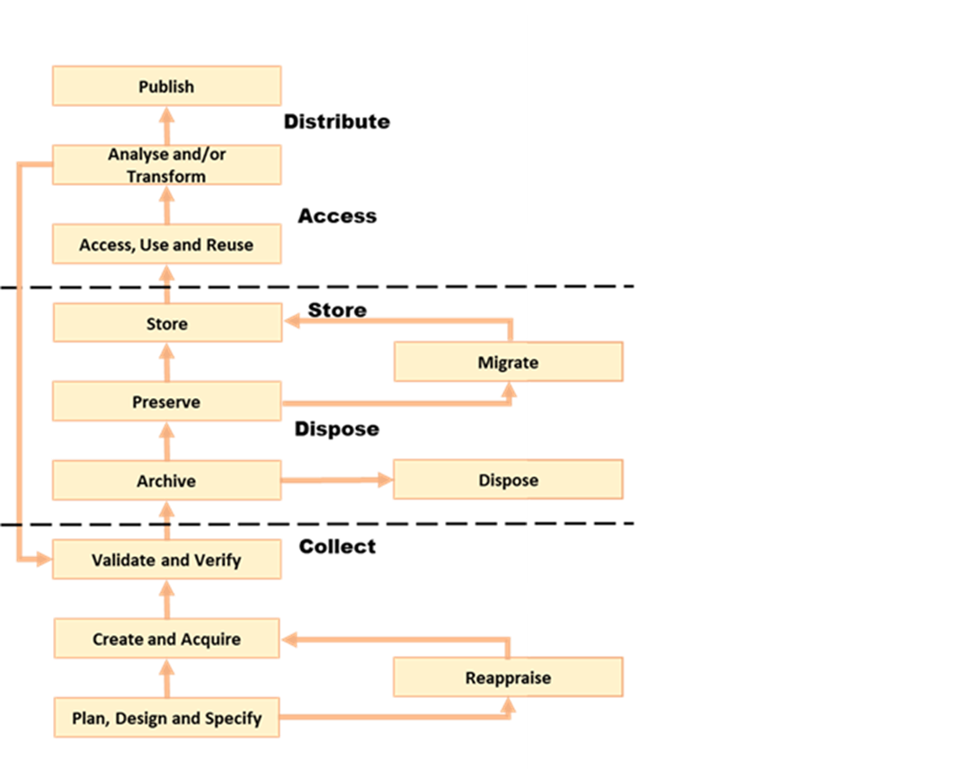

[*OGC O&M*](https://www.ogc.org/standards/om) */* [*ISO 19156*](https://www.iso.org/standard/32574.html) *(data observations and measurements)*

[*ISO 19165-1*](http://www.iso.org/standard/67325.html) *and* [*ISO 19165-2*](http://www.iso.org/standard/73810.html) *(digital data preservation), and* [*PROV*](https://www.w3.org/TR/prov-overview/) *to record history of data changers*

[*ISO 19157-2*](https://www.iso.org/standard/66197.html) *(data quality),* [*PROV*](https://www.w3.org/TR/prov-overview/) *to record history of data changers*

[*ISO 19115-1*](https://www.iso.org/standard/53798.html) *(data and services metadata),* [*W3C DCATv2*](http://www.w3.org/TR/vocab-dcat-2/)*for semantic web metadata capturing,* [*ISO 19110*](https://www.iso.org/standard/57303.html) *(methodology for feature cataloguing),* [*OGC Geopackage*](http://www.ogc.org/standards/geopackage) *(format for transferring Geospatial Information)*

**Applicable Standards (examples):**

[*ISO 19109*](https://www.iso.org/standard/53798.html) *(rules for application schema),* [*ISO 19131*](https://www.iso.org/standard/53798.html) *(Data product specifications)*[*, ISO 19115-1*](https://www.iso.org/standard/53798.html) *(data and services metadata),* [*W3C DCATv2*](http://www.w3.org/TR/vocab-dcat-2/)*for semantic web metadata capturing*

[*ISO 19157-2*](https://www.iso.org/standard/66197.html) *(data quality),* [*OGC O&M*](https://www.ogc.org/standards/om) */* [*ISO 19156*](https://www.iso.org/standard/32574.html) *(data observations and measurements)*

Figure 2.1: Geospatial data life cycle and examples of applicable standards (Amended from Source: Geospatial Frameworks)

## **Functions and Needs by Tier**

With reference to the tier diagram introduced in Direction Setting (Figures 1.5 and 1.6) and steps 2-3 of the 5 recommended steps (Table 2.1), the following subsections underscore the geospatial functional and standards needs which organizations could address depending on its tier and system maturity.

### **Tier 1 - Share Maps Internally and Over the Web**

Within a portal context, the most basic requirement is to be able to easily and effectively access and display geospatial information that may be stored in one or more databases and may use different vendor solutions and storage formats. Hence, the functions of visualization and portrayal, and subsequently catalogue and discovery are important at this tier. As identified in IGIF SP6 Appendix 6.3, potential needs at this tier could include:

* Visual overlay geospatial information as maps from different sources.
* Visualization of digital geospatial information as maps over the Web.
* Clear description of geospatial information (metadata).
* Discovery of geospatial information via online catalogs.
* Interoperability of internal and disconnected operations.

Therefore, the standards most widely implemented for Tier 1 are: [*OGC Web Map Service (WMS)*](http://www.ogc.org/standards/wms)*,* [*OGC Web Map Tile Service (WMTS)*](http://www.ogc.org/standards/wmts)*,* [*OGC Keyhole Markup Language (KML)*](http://www.ogc.org/standards/kml)*, and* OGC Geography Markup Language (GML) (also [ISO 19136](http://www.iso.org/standard/75676.html)).

Associated with visualizing geospatial information may be the requirement to portray the information using an organization’s symbology or cartographic presentation rules. There are available OGC standards to enable the ability to code, communicate and share visualization rules , such as [*OGC Styled Layer Descriptor (SLD)*](http://www.ogc.org/standards/sld), [*OGC Symbology Encoding*](http://www.ogc.org/standards/se)*,* and[*OGC Web Services Context (OWC)*](http://www.ogc.org/standards/owc). It is important to be aware that OGC web services while still broadly used worldwide are currently undertaking significant reform. The new OGC roadmap[22] focuses on the development of a family of [*OGC APIs*](http://ogcapi.ogc.org/) which will ‘make it easy for anyone to provide geospatial data to the web’. These standards, built upon the legacy of the *OGC Web Service standards (WMS, WFS*, etc.), define APIs to take advantage of modern web development practices.

Most organizations further enhance their capability to support geospatial information and service discovery as well as metadata creation and browsing functionality. Properly populated, standards-based metadata allows end-users. to determine if a specific set of information is “fit for purpose” for a particular use case. The key standard for metadata of geospatial resources which has been widely applied and adopted at regional and national levels is the ISO 19115-X series.

The ISO and OGC standards for catalogue and discovery are widely implemented in national, regional, and local SDIs. Most geospatial technology vendors, as well as open source solutions, support these standards. These standards should be implemented if the community requires the need to search metadata holdings for the geospatial information they require. The metadata catalogue or registry can be made available to services, including clients, using one of the *OGC Catalogue Service-Web (CSW)* profiles and/or the [*W3C DCAT*](https://www.w3.org/TR/vocab-dcat-2/) data catalog vocabularies.

### **Tier 2 - Geospatial Information Partnerships**

Once the desired geospatial information can be discovered and viewed as a seamless set of maps, then the infrastructure is mature enough to consider publishing content and transmitting data (content) to end users. In this Tier, the community and infrastructure have matured to the point that the services are stable and the community and partnerships are growing, requesting more functionality and capability. Potential organizational or SDI needs identified in IGIF SP6 Appendix 6.3 include:

* Ability to share detailed geospatial information within and with other organizations.
* Enhanced ability to apply geospatial data for improved situational awareness, analysis, and decision support.
* Ability to maintain and improve quality of common geospatial information between cooperating organizations.
* Organization agreements to share data using agreed upon standards-based data models.

For example, as more partners (public and private) wish to be part of a CoP to support collaborative sharing and maintenance of geospatial information content, the infrastructure of participating organizations will need to accommodate the use of additional international technology standards and community information model standards. At this stage, organizations would have to consider two of the three key types of geospatial standards:

* Information (or content) standards, and
* Technology (interface, API) standards.

An information model in software engineering is a representation of concepts and the relationships, constraints, rules, and operations to specify data semantics for a chosen domain of discourse, such as transportation, hydrology, or aviation. The goal of such models is to allow multiple stakeholders across many jurisdictions to have an agreement on how to express data for a specific domain, such as weather, geology, or land use. Such agreements significantly enhance interoperability and the ability to share geospatial information at any time and as required. For some time [*OGC Geography Markup Language*](https://www.ogc.org/standards/gml) */* [*ISO 19136*](https://committee.iso.org/sites/tc211/home/projects/projects---complete-list/iso-19136-2.html) *(GML)* Application Schemas and encoding has been the primary OGC/ISO standards-based approach used for modelling, encoding, and transporting geospatial information.

For geospatial information query and access, there are standards which allow the application and user to specify geographic and attribute queries and request that the geospatial information be returned as an encoding. Recommended standards to support this capability can be found in the Standards Inventory ([Appendix 1](https://drive.google.com/file/d/1DAb4QinqlEecqFzvtqi7JpnX7zzpdZJM/view?usp=sharing)) and elaborated in the Taking Actions section later in this Guide.

Common distribution formats are [*GML*](http://www.ogc.org/standards/gml), [*ISO 8211*](https://www.iso.org/standard/20305.html) (used by [*IHO S-57 and IHO S-100*](http://iho.int/en/standards-and-specifications)), [OGC *GeoTiff*](http://www.ogc.org/standards/geotiff). International open standards are better than proprietary or locally defined formats as they reduce costs and enhance collaboration with outside groups. There are also standard ways for requesting geospatial information, packaging that information, and transmitting the information. For example, if the user wants the transportation theme as a GML dataset or a chart in IHO *S-101* or *S-57*, then the server-based software needs to be able to generate the information in the requested formats. These requests for publication are performed using simple web calls. Distribution can be in any number of standard formats, such as *GeoTIFF* or *GML* files. The required data can be streamed from the server to the client application or for very large files can be uploaded to an ftp site or accessed through flexible web file sharing services (e.g., API) at any time.

**Domain-Specific Data Models**

At Tier 2, organizations should consider abstract standards or models that describe such geographic information elements as geometry (points, lines, polygons), coordinate reference systems, data quality, time, and so forth. Similarly, domain data modelling extends information modelling by enabling the reuse of concepts, semantics, and information organization (schemas) between related systems. While information modelling typically refers to modelling just one system, domain modelling involves the practice of creating definitions of concepts which are reused between multiple systems. In the standards context this is further extended to imply interoperability of models and platform independence.

Both information models and domain models are relevant to Tier 2 and Tier 3 in the evolution of an SDI. Using such domain-specific, information or content standards helps to guarantee that geospatial information can be encoded and shared with consistent semantics, geometry, quality, and provenance. Further, data models tend to be encoding tools agnostic, meaning the content can be encoded using XML, JSON, and other encoding technologies. Examples of these models include [*OGC CityGML 2.0*](https://www.ogc.org/standards/citygml)*,* [*ISO 19152 LADM*](https://www.iso.org/standard/51206.html)*,* [*OGC LandInfra/InfraGML*](http://www.ogc.org/standards/infragml)*,* [*IHO S-100 General Feature Model and Geospatial Registry*](https://iho.int/en/standards-and-specifications)and [*IHO S-57*](https://iho.int/en/standards-and-specifications) *Transfer Standards for Digital Hydrographic Data*[*.*](https://iho.int/en/standards-and-specifications)

To summarize, domain-specific standards and content data models refer to community agreements on the elements, relationships between elements, semantics and so forth for a specific data set in a given domain. The models are implementation independent and vendor neutral. In order to automate and make the exchange of domain specific geospatial data seamless, consensus needs to be built among the community participants on:

* A shared data model for data exchange, in terms of a common understanding and agreement for how different systems “understand” each other.
* Common definitions of the different data entities and their properties.
* Common controlled vocabularies and taxonomies.

In the case of a transportation network, common agreements and vocabularies mean that:

* All stakeholders agree on how to display (symbolize) the transportation network.
* All stakeholders agree to what each attribute, such as road width, means in terms of the shared view of the transportation network.
* All stakeholders agree to a common view of the road classification system.

This use of common data models is part of the natural evolution and progression of an SDI that leads to the concept of foundation or framework SDI data themes. This evolution is described in greater detail in the Tier 3 discussion. Good references on the domain modelling and content models are [*ISO 19109, Geographic information – Rules for application schemas*](http://www.iso.org/standard/59193.html) and the [*OGC OWS-8 Domain Modelling Cookbook*](https://portal.ogc.org/files/11-107). These documents describe rules and good practices for building and maintaining inter-related domain models, which have dependencies on multiple systems. They describe how to build interoperable, maintainable domain models, the challenges and pitfalls faced in building these models, the techniques and patterns that should be applied, and specific tools that can be used.

These agreements enable specific organizations to avoid changing their software or processes by agreeing on a shared data model and semantics (vocabulary, terms and definitions, etc.) used in the model. There are currently many such models available that have been developed and agreed to by international organizations or communities. These models should be considered first prior to considering the development of new data models.

### **Tier 3 - Spatially Enabling the Nation**

In this Tier, the infrastructure is mature enough to: (1) provide access to multiple themes of information via a variety of environments (e.g., mobile, desktop); (2) support deployment of more applications to enhance value, provide increased citizen benefit, increase collaboration between organizations; and (3) integration of an increasing number of geospatial information resources, including volunteer, crowdsourced and real time sensor feeds. Completion of the needs assessment and gap analysis template described in IGIF SP6 Appendix 6.3 would have identified potential needs including:

* Delivery of “foundation” or “framework” geospatial information.
* Provision of geoprocessing services to perform spatial analysis and modeling.
* Development of mobile applications.
* Integration of real-time sensor feeds.
* Customized products and applications.

Standards are available to facilitate implementation of geoprocessing and analytics services, grid systems, mobile applications: capturing and integrating real-time sensor data, and geosemantics. These trends are further elaborated in the ‘Taking Action’ chapter and relevant standards or frameworks can be found in [Appendix 1](https://drive.google.com/file/d/1DAb4QinqlEecqFzvtqi7JpnX7zzpdZJM/view?usp=sharing).

1. **Geoprocessing & Analytics** – [*OGC Web Processing Service (WPS)*](http://www.ogc.org/standards/wps)and[*OGC Web Coverage Processing Service (WCPS)*](http://www.ogc.org/standards/wcps)
2. **Grid Systems** – [*OGC Discrete Global Grid Systems*](http://docs.opengeospatial.org/as/15-104r5/15-104r5.html)and [*ISO 19170-1*](http://www.iso.org/standard/32588.html)
3. **Mobile Applications** – [*OGC Open GeoSMS*](http://www.ogc.org/standards/geosms) and[*OGC GeoPackage*](http://www.ogc.org/standards/geopackage)
4. **Real-Time Sensors** – [*OGC Sensor Web Enablement (SWE)* standards](http://www.ogc.org/node/698) and [*OGC SensorThings API*](http://www.ogc.org/standards/sensorthings)
5. **GeoSemantics -** The [Spatial Data on the Web Interest Group](http://www.w3.org/groups/ig/sdw) (W3C/OGC) is one of the communities that provides significant input to development of good practices and vocabularies that encourage better sharing of spatial data on the Web; and identify areas where standards should be developed jointly by both W3C, OGC and ISO, including [*OGC GeoSPARQL*](http://www.ogc.org/standards/geosparql)*,* [*OGC API Features*](http://www.ogc.org/standards/api-features)*/*[*ISO 19168-1*](https://www.iso.org/standard/32586.html) and *ISO* [*19150-1*](http://www.iso.org/standard/57465.html)*/*[*19150-2*](https://www.iso.org/standard/57466.html)*/*[*19150-4*](https://www.iso.org/standard/72177.html).

An excellent example of operational use of OGC SWE standards is the [Debris Flow Monitoring System](https://docs.opengeospatial.org/guides/19-050.html) deployed in Chinese Taipei. This program uses OGC Web Services and OGC SensorThings standards integrated into a monitoring, modelling, and alerting infrastructure. (See also: <https://youtu.be/6Hb2iXQQ8TY>).

### **Tier 4 - Towards Spatially Enabled IT Infrastructure**

Tier 4 involves the transition of current SDI into a broader Spatial Knowledge Infrastructure (SKI) that can be strategically planned based on: (1) emerging standards and technology trends that are addressing known gaps, challenges and needs (refer to Direction Setting chapter - Emerging Standards and Trends); (2) delivering geospatial information into the Web of data and bridging the SDI to a broader ecosystem of

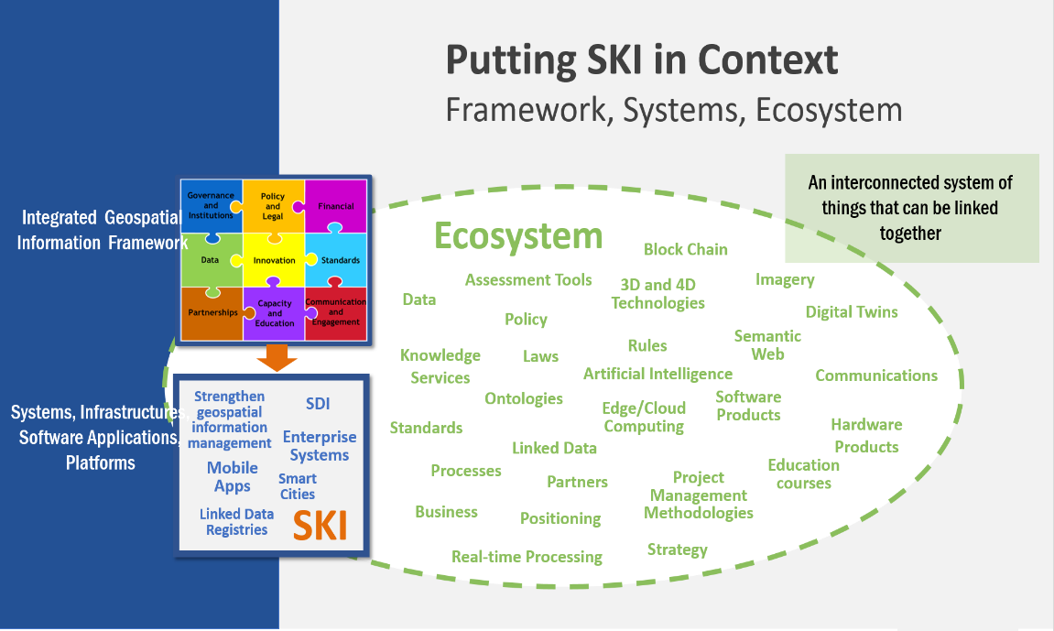information systems (Figure 2.2), and (3) The SDI to SKI -Maturity Matrix (Figure 2.3). A

Figure 2.2: Putting SKI in Context

‘needs assessment and gap analysis template’ described in IGIF SP6 Appendix 6.3 has identified two potential needs of an SDI at the Tier 4 level:

* Establishment and implementation of standards for the global geospatial information community
* 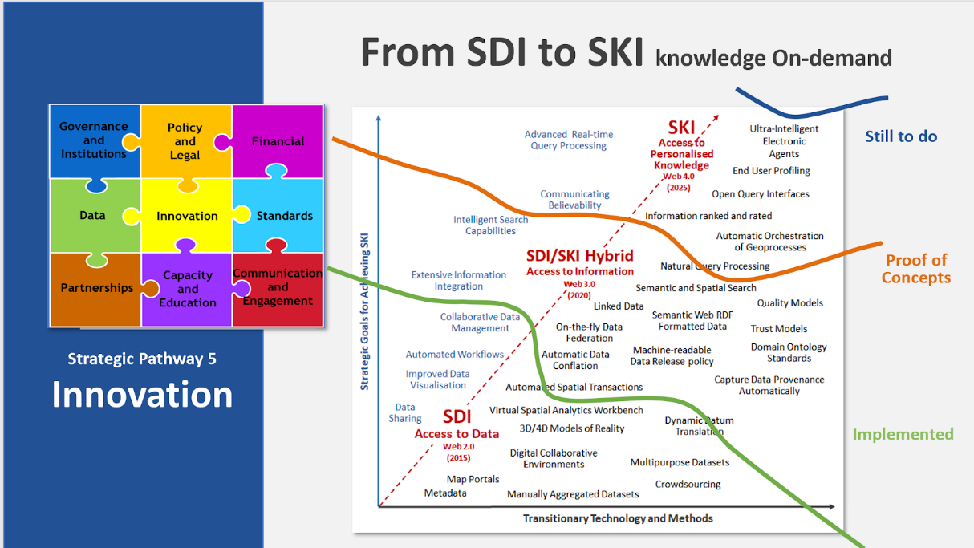Understanding and preparation for emerging standards, good practices, and trends.

Figure 2.3 From SDI to SKI – Maturity Matrix

Standards are constantly being produced and updated based on prevailing technologies and user needs and challenges. The SDOs - ISO/TC211, OGC, IHO and W3C have online standards registries where the latest standards and information are made available and accessible ([Appendix 5](https://drive.google.com/file/d/17y36KQj7bX_anDeDf-hGkbJbEVlPeySY/view?usp=sharing)). Trends are driving requirements for enhancing existing geospatial standards, rethinking and crafting a new generation of standards based on the lessons learned of the existing baseline. It is also opportune that the implementation of a new suite of standards leverages the value of the emerging ecosystem of technologies and user requirements.

The bridging of the SDI and broader ecosystem of knowledge information systems can be done at the web services/API or database level. There are existing suites of standards that could kickstart enhancement of SDIs for future SKI capabilities. For instance: **OGC APIs** as well as new and upcoming Tier 4 standards are included for review in [Appendix 6](https://docs.google.com/spreadsheets/d/1wKoIqQWX_T4F9mXGS4gRRF5bwxyOk6PC4TCg5BzEWPk/edit?usp=sharing).

# **Planning for Change**

|  |
| --- |
| The purpose of this section is enabling the reader to understand:   * How other nations or organizations have implemented and used standards to meet their needs. * The types of business needs that may be supported through the implementation of standards, advocating for the adoption of standards to facilitate interoperability and other efficiencies. * The importance of considering and implementing standards as part of the systems development lifecycle, and the importance of contributing to and providing feedback to the development of standards through direct participation and provision of feedback. * How to play a role in the identification of opportunities for standardization in the context of their domain, and act as advocates to engage related communities of practice to facilitate alignment and interoperability at various levels. |

Properly functioning geographic information management operations include well governed selection and adoption of open standards, and prioritized engagement in developing international (and where necessary) national standards, along with guidelines, skills development, supporting software, and a functioning CoP.

To achieve this, the following components are required:

* Governance across the national framework, including central government, devolved (regional) administrations, local government, and technical implementing organizations.
* An endorsed national policy and legal framework.
* Leadership for each part of the national framework, including the standards pathway.
* An active communications plan.
* Bridges to the international and national standards bodies.
* Mechanisms to influence adoption, such as spend controls and local government information standards.
* Partnerships with industry to develop tools.
* Partnerships with universities and professional bodies to deliver skills training.
* An underpinning and sustainable financial plan, including clear management of benefit realization.

## **Institutional Arrangements**

### **Governing Bodies**

It is important for implementing organizations to recognize the many interested parties that have different roles in governance. Examples of governance bodies relevant to standards for geospatial information management include:

* The national lead organization for geospatial initiatives (e.g., development and/or setting national standards, implementation of national SDIs and/or coordination between SDIs at the national level, etc.).
* The national lead department for digital government, data, or information technology.
* The government office responsible for implementing digitalization of government services.
* 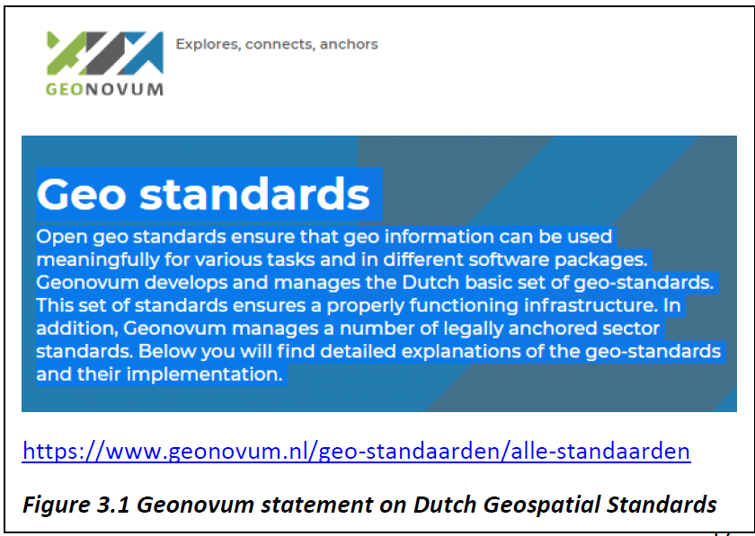Any government or semi-government body already responsible for data or IT standards.
* Specific departments based on the role of geospatial data and information in their business.

Other bodies may also have a strong role to play:

* The national standards body,
* Bodies responsible for higher level technical training,
* Relevant professional bodies.

One of the first steps in the planning process is to confirm the organizational governance roles, structures, and processes to organize and guide the implementation of the action plan. It is important to ensure that the foundation is in place to be able to set up project oversight and implementation structures (implementation and persistent governance structures and teams), assess and determine scope and resource requirements to deliver on the action plan (including post-implementation), and implement changes outlined in the action plan.

Examples of key activities include:

* Ensure that all roles, responsibilities, and organizational structures are in place according to national policy and plan to foster a successful implementation.
* Identify the level of organizational capability required to meet the mission (see Section 2 on Understanding Needs).
* Define the level of organizational engagement and resources necessary for participation in the national governance process, as described in IGIF SP6 section 6.6.1, for successful cooperation between national agencies and stakeholders for sharing and exchanging geospatial data.
* Ensure that acquisition/procurement actions include requirements for common nationally endorsed standards.

**Roles and Responsibilities for National Standards Governance**

The governance of standards is a collaborative system involving stakeholders from governmental organizations, industry and academia, technologists and domain experts, SDOs, and the general public. Activities range from defining the requirements for standards, standards development and feedback, adoption, and implementation, and verifying compliance, and development and implementation of guiding policies and implementation artifacts (e.g., legislature, etc.). Annex 6.4 of the IGIF provides examples of typical roles and activities, and their relevance to governance for standards.

### **Bridges – Linkages to Standards Bodies**

These ensure that international policy and standards are well understood within the country, and that the international standards bodies understand any specific issues relevant to your country.

Where bridges lead will depend on the set of standards deemed to be important. Engagement with organizations such as OGC and W3C may be direct, while engagement with ISO, IHO, or IETF may require a ‘bridge’ such as a national mirror committee that may be managed by a national standards body. Such committee may require a national government representative, for instance from the national standards body, to participate on behalf of all organizations in a nation.

### **Mechanisms to Influence Adoption**

Adoption of standards by individual organizations can be influenced through many strategies, such as:

* **Directives** - adoption based on legal or other mandated requirements.
* **Negotiation** - between partners, within a CoP, etc.
* **Certification, compliance** - these may come in the form of requirements or provide value such as competitive advantage to the organization.
* **Engagement**- demonstrate value of adoption, education and raising awareness.
* **Spend controls** - invest or withhold funding based on support needed to adopt or consequence of not being compliant.

Although it would be desirable for organizations to simply believe in and adopt standards because it is the right thing to do, this approach is generally not practical. There tends to be sufficient flexibility in relevant standards to enable fine tuning the implementation to meet the organization’s needs (e.g., profiles of the *ISO 19115-1 Metadata* standard are one such example). Furthermore, when the intent is to achieve interoperability through adoption of standards by cooperating organizations in a community, goodwill alone tends to be insufficient. Therefore, a mix of clear direction, coupled with strong community engagement must be incorporated into any national action plan.

* Adoption by the central government can be influenced through direction and spend controls, which may depend on a national technology code of practice. Governance for geographic data should fit in with this national control.
* Adoption by devolved administrations can be influenced through negotiation, certification requirements, engagement, and other means.
* Adoption by local authorities can be influenced through negotiation and engagement via a national coordinating body, the local government information standards organization, etc. This may include councils, police, fire, health etc.
* Adoption by the private sector can mainly be influenced via national geospatial standards policy (endorsed standards), and via acquisition language (e.g., mandatory application of specific standards). Professional education also has a part to play, both at an initial level through university courses, and an ongoing level through professional bodies for geographic information, surveying, cartography, geography, IT, project management.

## **Action Plan**

The work leading up to an adopted plan of action typically involves generic project planning activities consistent with those employed on any change initiative. An important first step of any action plan is to define its outcomes - what the Action Plan should ultimately achieve. The IGIF SP6 describes two perspectives which contribute to the overall outcomes of the plan, Business Capabilities and Technical Capabilities. The capabilities needed or desired by an organization may be impacted by many factors. The business and technical capabilities outlined in this document are organized according to their typical implementation, supporting a stepwise evolution starting with small scale (single organization/community) and incrementally adding capabilities required to work across larger communities (multiple organizations).

Large-scale change initiatives may have impacts on the organization in many ways. In terms of standards, key questions to be considered in the planning process include:

* **What**: What are the expected outcomes of the action plan? It is critical to consider the desired outcomes of the action plan from various perspectives. The IGIF SP6 and Understanding [Organizational Standards] Needs section in this document provide examples of outcomes from the technical (e.g., infrastructure capabilities, interoperability, etc.) and business (e.g., single to multi-organizational or jurisdictional coordination, etc.) perspectives, though there may be others to consider.
* **When**: When do we intend to reach our goals or different steps? It is important to establish an implementation strategy and schedule that reflects the chosen approach. The Direction Setting and Understanding [Organizational Standards] Needs sections of this document outline potential objectives for the action plan and in some cases, such as the geospatial tiers, these are presented in a manner that lend themselves to a stepwise implementation. It is important to consider factors including the impact and complexity of the desired change(s), the realities faced by the entities impacted by the desired change(s), any factors which impact how the change must be implemented, and the relative priorities of desired changes and where those changes are implemented. Stepwise approaches may take longer to fully implement but can involve significantly less risk than ‘big bang’ implementations. Planning organization level change such that successes are achieved and promoted early is key to maintaining momentum through delivery of results. When all factors are considered, an implementation schedule with milestones should be developed, communicating the schedule, priorities, and key checkpoints used to monitor progress.
* **Who:**Who are the key experts and decision-makers needed to support the activities identified? When considering the delivery of any change initiative, it is critical to understand those leading, implementing, and impacted by the change. Examples of such stakeholders include:
  + Governance and policy bodies as defined in the IGIF SP6.
  + Experts needed for developing information models, specifications, and IT environments.
  + Organizations providing experts.
  + Organizations responsible as authoritative data owners.
  + Reference groups and stakeholders.

In addition to identifying the key stakeholder groups and their respective roles(s), it is also important to consider whether individual stakeholder groups are supportive or oppose the strategic direction proposed in the action plan. Supportive stakeholders can act as champions for change, while opposition must be managed as risk. Ensuring support and progress requires active engagement, with greater investment made to manage areas of risk.

* **Costs and funding:** What are the costs? What types of costs? How is the national plan funded? Even after the project scope, schedule, and stakeholders are identified, it is important to consider the one-time and ongoing costs to implementing the national plan and how the work will be sustained into the future. Costs may be direct (procurement of IT infrastructure, procurement of or modification to IT systems, changing needs for human resource), indirect (changes to business processes, governance structures), and may be attributed to the action plan or considered in-kind exchanges.

The assessment of the types and anticipated costs not only supports the justification necessary to ensure the availability of resourcing to implement and sustain the results of the action plan, but also serves as a reference for discussing costs with stakeholders, particularly those that see cost as a major barrier to the action plan or their participation.

* **Relation to other initiatives or activities:** A major national project will have an impact on other ongoing projects, and there can be both synergies and challenges to deal with. Certainly, relationships to the implementation of other Strategic Pathways at a national level will be highly relevant. Engagement with other relevant initiatives or activities provides an opportunity to implement consistent messaging on topics of agreement and investigate differences prior to engaging stakeholders.

It is important to promote and seek alignment between independent efforts whenever possible, and where there are differences that cannot be fully resolved, frame them to support those involved. This typically requires additional supporting context and engagement for impacted stakeholders to understand the differences and the rationale. Unresolved differences must be handled with care as these may impact the implementation of the national plan (e.g., avoid leaving individual organizations to choose between the action plan and an independent initiative).

* **Capacity Building**: What is the approach for capacity building and what tools and resources are available? As the action plan is implemented, it is important to provide support to participants to ensure their successful engagement with the project. The Ongoing Management section of this document outlines key maintenance activities necessary to ensure that implementations of standards continue to perform optimally, specifically the standards review process and the role of communities of practice. The action plan should also include feedback and other mechanisms needed for the project to respond to any issues raised during its implementation.

# **Taking Action**

|  |
| --- |
| The purpose of this section is enabling the reader to:   * Understand the level of maturity of the nation and/or organization and thereby the level of complexity and the potential work that needs to be done during the implementation phase. * Match the standards required to fulfill their needs to a given maturity level, * Understand details about what standards are needed and applicable in different cases, how to access the standards, and how to take the essential steps to implement those standards. * Understand the standards and provide feedback into the ongoing development of the implemented standards. |

## **Implementation**

This section describes which standards may be appropriate to use in each of the Tiers as identified in Figure 1.5. The list of standards provided is not intended to mean that every standard is mandatory at each Tier. Instead, these are meant as recommendations. For example, a number of standards are listed for Tier 1 (see [Appendix 1](https://drive.google.com/file/d/1DAb4QinqlEecqFzvtqi7JpnX7zzpdZJM/view?usp=sharing)). Of the list provided for Tier 1, an initial SDI implementation may only implement one or two of the suggested standards. Further, standards recommended in Tier 2 could be implemented in Tier 1 and vice versa. The final decision as to which standards are implemented must be based on specific requirements and use cases.

## **Foundational Standards**

Important to mention are two categories of standards that can be called “foundational”, which means they support all Tiers. They are:

* **General information technology and Internet standards** on which geospatial standards may be dependent. While not all of these standards may be required for implementation, they may be required within an implementing community’s operational environment.
* **General Geospatial Standards** which include good practice standards regarding geospatial data definitions, representation, data quality, general architecture and other aspects of geospatial information and technology. They collectively provide guidance on geospatial data collection, production, and maintenance.

General IT and Internet standards are required to implement any web or internet-based solution. No information technology standards exist in isolation. There is a rich standards stack that supports all internet, web, and/or mobile applications. These standards are listed as “General IT” in [Appendix 1](https://drive.google.com/file/d/1DAb4QinqlEecqFzvtqi7JpnX7zzpdZJM/view?usp=sharing).

General geographic information standards provide key concepts of geospatial information definition, organization, and architectural representation. These standards are listed as “General Geospatial” in [Appendix 1](https://drive.google.com/file/d/1DAb4QinqlEecqFzvtqi7JpnX7zzpdZJM/view?usp=sharing).

Please note that not all of these standards are required for implementation, but they may be required or expected to be present in a community’s operating environment. Furthermore, most OGC standards reference one or more of these foundational standards.

## **Tier 1 - Share Maps Internally and Over the Web**

**Tier 1 Goal** – The most fundamental requirement in Tier 1 (see fig. 4.1) is to enable the stakeholders and constituents (users) of an organization or institution to view and query interactive maps on the web. A [map](https://en.wikipedia.org/wiki/Map) is a depiction (i.e., an image) representing geospatial facts, provided for human consumption. Beyond this human-centric service and closely associated with this fundamental requirement is the general ability to discover, share and use geospatial information, including (but not limited to) machine-readable representation.

An organizational or institutional goal is to provide staff, partners, and customers with the ability to view and query geospatial information in existing client applications using a variety of devices such as a desktop, tablet, or other mobile devices. This can include information developed by an organization itself or web accessible data available from other organizations. By using a web browser or smartphone, users can look up different “layers” of information. They can display, zoom into points of interest, and print maps while keeping their organizational IT infrastructure intact. As more maps are published, catalogs become necessary to enable map providers to advertise the availability of their maps and users to find them.

To achieve this goal, there are some basic requirements that must be met. The same terminology and semantics must be used. The data must be modelled in a way that makes it possible to access and display data across platforms and formats.

The capabilities of Tier 1 are:

* Harmonized terminology and semantics
* Data modelled and described based on harmonized terminology and semantics
* Clear description of geospatial data (i.e., metadata)
* The ability to discover metadata via on-line catalogs
* The ability to visualize digital geospatial information as maps over the Web, from a single source or overlaid from several different sources.

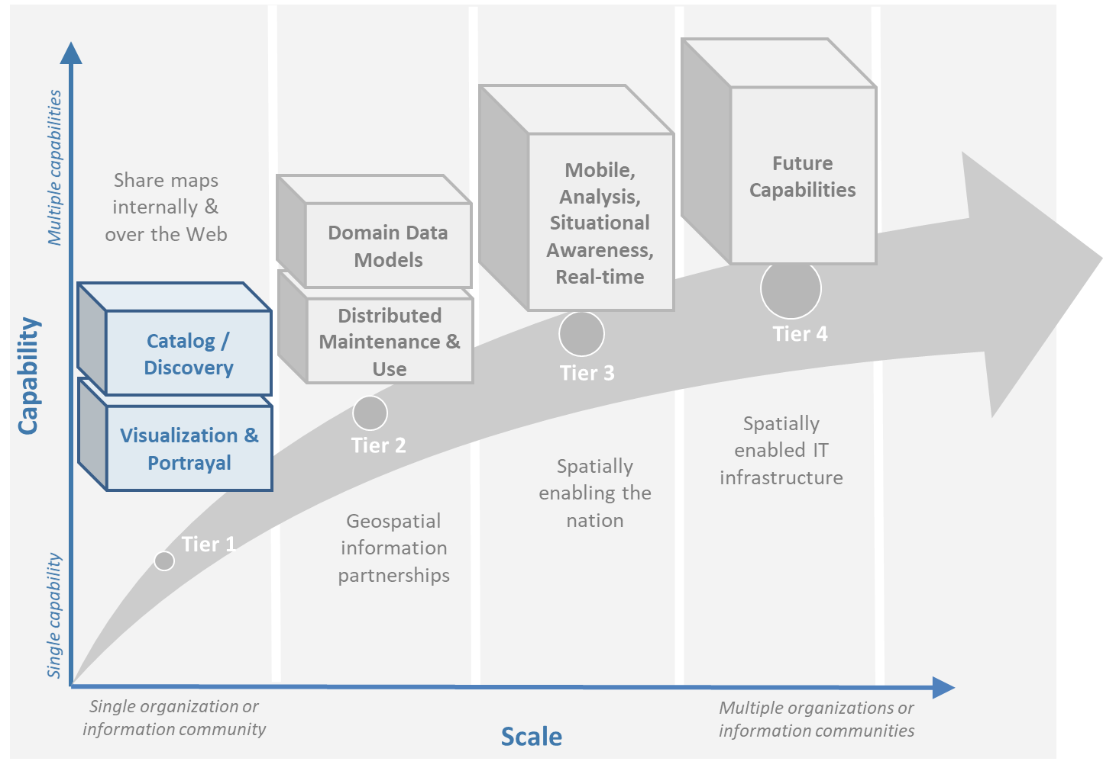

*Figure 4.1 Tier 1 Capabilities Enabled by Standards*

Listed below are a few features and benefits that a Tier 1 solution can fulfill:

* Establishing a simple, low-cost way to share and view geospatial information as images with stakeholders and constituents.
* The ability to implement solutions that enable any desired combination of standards-based geospatial technologies - enabling interoperability.
* Storing and managing Geospatial information locally in a preferred format, with no need to incur the time and expense of reformatting geospatial information into a single required format.
* Allowing geospatial data to remain with the owner and maintainer of the data to increase the likelihood of update.
* The ability to publish maps for on-line government and citizen access.

At this initial level of capability, policy and governance related to geospatial information management and operations may be somewhat informal.

The following represent some implementation considerations regarding the capabilities depicted for Tier 1 in Figure 4.1.

### **Visualization and Portrayal**

The most basic requirement in an SDI is to be able to easily and effectively access, integrate, and display geospatial information that may be stored in one or more databases using different geospatial technology solutions and storage formats. Of the Tier 1 standards listed in [Appendix 1](https://drive.google.com/file/d/1DAb4QinqlEecqFzvtqi7JpnX7zzpdZJM/view?usp=sharing) table 4.1, by using just [*OGC WMS*](http://www.ogc.org/standards/wms) an organization can generate web-based applications that provide access to spatial information holdings, regardless of the formats used or GIS technology deployed. Many organizations have implemented *OGC WMS* first to provide seamless access to geospatial information. These deployments provide quick, short term success and return on investment. If the data that an organization wants to display on the internet are already organized in tiles, then there is also the possibility of using [*OGC WMTS*](http://www.ogc.org/standards/wmts). As implementations mature, most organizations can enhance their SDI capability with discovery and metadata browsing capability.

The Tier 1 standards recommended for implementing powerful access, browsing, visualization and display capability are listed in [Appendix 1](https://drive.google.com/file/d/1DAb4QinqlEecqFzvtqi7JpnX7zzpdZJM/view?usp=sharing). These standards provide the ability for the user to access and display geospatial information as images in any browser.

### **Catalogue and Discovery**

The ISO and OGC standards for catalogue and discovery are widely implemented in national, regional, and local SDIs. Most geospatial technology vendors and open-source solutions support these standards. Implementation of these standards, listed in [Appendix 1](https://drive.google.com/file/d/1DAb4QinqlEecqFzvtqi7JpnX7zzpdZJM/view?usp=sharing) and table 4.1 are required to provide the ability to search metadata holdings for specific geospatial information of interest. The metadata and catalogue searches also allow the user to determine if the geospatial information is fit for a particular use or purpose.

The content of a catalogue is metadata. Metadata is a description of a resource, in this case a geospatial resource. The catalogue provides the services to search and publish the metadata for data, services, and related types of data.

|  |  |
| --- | --- |
| **Technology in Tier1** | **Relevant Standard** |
| Visualization and Portrayal | OGC Web Map Service |
| OGC Web Map Tile Service |
| OGC Styled Layer Descriptor |
| OGC Symbology Encoding |
| OGC Web Services Context Document |
|  | IHO S-100 Part 9 – Universal Hydrographic Data Model Part 9 - Portrayal |
| Catalogue and Discovery | ISO 19115-1:2014, Geographic information — Metadata — Part 1: Fundamentals |
| ISO 19115-2:2019, Geographic information — Metadata — Part 2: Extensions for acquisition and processing |
| ISO 19115-3:2016, Geographic information - Metadata - Part 3: XML schema implementation for fundamental concepts |
| OGC Catalogue Service |
| Data Catalog (DCAT) Vocabulary Version 2 |

Table 4.1 Standards in Tier 1, for standard descriptions see [Appendix 1](https://drive.google.com/file/d/1DAb4QinqlEecqFzvtqi7JpnX7zzpdZJM/view?usp=sharing)

## **Tier 2 - Geospatial Information Partnerships**

Tier 2 Goal (see Figure 4.2) -- An information community wishes to provide access to geospatial information over the Web, provide geospatial information download services, and in addition, may wish to collaborate across jurisdictions on maintenance and update of specific data themes, such as roads, from multiple sources that conform to agreed upon standards-based data models to create a consistent and integrated definition or meaning of the geospatial information for users.

The main drivers for a move from Tier 1 to Tier 2 are:

1) The need to share geospatial data rather than maps in order to support more detailed analysis forecasting and other more powerful decision support applications, and

2) The desire to achieve interoperability within a community based on agreed upon standards-based data models for data exchange and maintenance.

Organizations may wish to publish their geospatial information on the web. Furthermore, one or more organizations may wish to work with other members of a community to build, share, maintain and use datasets that provide a common operational view of important issues such as safe navigation, flood control, road maintenance, disaster management or bush fire management and response. Using this approach, data providers do not need to adopt the same technology solutions or change their database structures provided that they conform to agreed upon standards and data models. Through the use of Tier 2 open standards, they can provide access to view, distribute, or share geospatial information that conforms to these 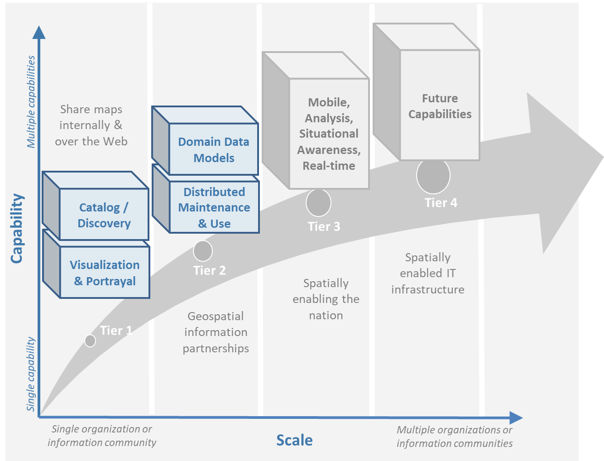agreed upon standards-based data models.

*Figure 4.2 Tier 2 Capability Enabled by Standards*

As a result of the approach described above, users accessing geospatial content delivered in this way will be able to view, process and analyze geospatial information seamlessly, even though the data may be provided from multiple sources. Other user communities requesting geospatial information will receive the content in a common structure (format), which will facilitate its use in additional end user applications.

In addition to Tier 1 capabilities, Tier 2 capabilities include:

* Access to geospatial information for viewing, analysis and other applications can be provided to all stakeholders and constituents using a consistent, well documented standards-based approach.
* Publishing of geospatial information is enhanced by adherence to agreed upon data content models for distribution and application. Content owners do not need to change their underlying models, nor do they need to change their current geospatial technology provider (unless that provider does not provide standards-based approaches).
* Overall costs are reduced since existing geospatial technology can be leveraged.
* Existing geospatial information can be repurposed, with reduced reliance on format translation, and with enhanced quality of data and services.
* Access to geospatial information and services can be controlled through access authorization.
* Collaborative data maintenance capability is enabled (see below).

The following key standards are recommended for possible use in Tier 2 (see Table 4.2 for more detailed list).

### **Distributed Maintenance and Use**

The goal of information models is to allow multiple stakeholders across many jurisdictions to have an agreement on how to express data for a specific domain, such as weather, geology, or land use. Such agreements significantly enhance interoperability and the ability to share geospatial information at any time and as required. Followings are some examples of the standards that can be implemented for sharing geospatial information.

For information modelling and encoding: [*GML*](http://www.ogc.org/standards/gml) is the primary OGC/ISO standard used for modelling, encoding, and transporting geospatial information. In addition, a number of OGC standards reference and use [*OGC Observations and Measurements*](http://www.ogc.org/standards/om) *(O&M) (also ISO*  [*19156*](https://www.iso.org/standard/32574.html) *)* is discussed as part of the Tier 3 standards recommendations. While O&M is used by a number of Tier 2 recommended standards, knowledge of this standard is not required until Tier 3.

* [*OGC*](http://www.ogc.org/standards/gml)*/*[*ISO 19136*](https://www.iso.org/standard/75676.html) *Geography Markup Language (GML)* is XML grammar for expressing geographical features. GML serves as a modeling language for geographic systems as well as an open interchange format for geographic transactions on the Internet.

For geospatial information query and access: The following standards allow the application and user to specify geographic and attribute queries and request that the geospatial information be returned as an encoding.

* [*OGC*](http://www.ogc.org/standards/wfs)*/*[*ISO 19142*](https://www.iso.org/standard/42136.html) *Web Feature Service 2.0* – allows requests for geographical features across the web using platform-independent calls.
* [*OGC*](http://www.ogc.org/standards/fe)*/*[*ISO 19143*](https://www.iso.org/standard/42137.html) *Filter Encoding 2.0* – allows the user/application to specify and communicate geospatial information queries using a standard language.
* [*OGC Web Coverage Service (WCS) 2.0*](http://www.ogc.org/standards/wcs) – A WCS specifies standard rules and operations for access to coverage data such as digital elevation models, multi-spectral satellite images, and other surface covering tessellations.
* [OGC/ISO 19169 API Features](http://www.ogc.org/standards/ogcapi-features) - offers the capability to create, modify, and query spatial data on the Web and specifies requirements and recommendations for APIs that want to follow a standard way of sharing feature data.

### **Domain Data Models**

Both information models and domain models are relevant to Tier 2 and Tier 3 in the evolution of an SDI. Using such domain-specific, information or content standards helps to guarantee that geospatial information can be encoded and shared with consistent semantics, geometry, quality, and provenance. Some domain models are agreed between countries, such as the INSPIRE Data Specifications, or by international organizations such as the World Meteorological Organization. Further, data models tend to be encoding tools agnostic, meaning the content can be encoded using XML, JSON, and other encoding technologies. Examples of these models include [OGC CityGML 2.0](https://www.ogc.org/standards/citygml), [ISO 19152 Geographic Information - Land Administration Domain Model (LADM)](https://www.iso.org/standard/51206.html), [OGC LandInfra/InfraGML](https://www.ogc.org/standards/infragml) and [IHO S-100 Part 9 – Universal Hydrographic Data Model Part 3 - General Feature Model](https://iho.int/uploads/user/pubs/standards/s-100/S-100_Version_1.0.0.pdf).

|  |  |
| --- | --- |
| **Technology in Tier2** | **Relevant Standard** |
| Distributed Maintenance and Use | OGC GML/ISO 19136:2007, Geographic information — Geography Markup Language (GML) |
|  | OGC Web Feature Service/ISO 19142:2010, Geographic information — Web Feature Service |
|  | OGC API Features /ISO 19168-1:2020, Geographic information — Geospatial API for features — Part 1: Core |
|  | OGC Filter Encoding/ISO 19143:2010, Geographic information — Filter encoding  OGC Web Coverage Service |
|  | OGC GeoTIFF |
|  | OGC GeoPackage |
|  | IETF GeoJSON |
| Domain Data Models | OGC CityGML |
|  | OGC LandInfra/InfraGML |
|  | ISO 19152 Geographic Information - Land Administration Domain Model (LADM) |

*Table 4.2 Standards in Tier 2, for standard descriptions see* [*Appendix 1*](https://drive.google.com/file/d/1DAb4QinqlEecqFzvtqi7JpnX7zzpdZJM/view?usp=sharing)

## **Tier 3 - Spatially Enabling the Nation**

**Tier 3 Goal** (see figure 4.3): Multiple organizations may share foundation/framework geospatial information and services with each other and the broader community to improve knowledge and understanding, thereby contributing to evidence-based decision making, situational awareness, and improved societal outcomes.

Implementations in Tier 3 (see Figure 4.3) allow participants and stakeholders to extend the value of their geospatial information assets by sharing these assets with others, thereby leveraging geospatial information from other providers. Groups working in different application domains are able to share their data, discover and access data produced by others, and benefit from improved understanding and knowledge. The same geospatial information that is needed for land use planning may also have value for flood prevention and mitigation, environmental monitoring and remediation, efficient transportation and logistics, and public safety. Organizations can also improve their understanding and awareness of rapidly changing events by incorporating new information sourced from smartphones, as well as information from mobile and static sensors. Incorporation of crowd-sourced or Volunteered Geographic Information (VGI) geospatial information can be accommodated.

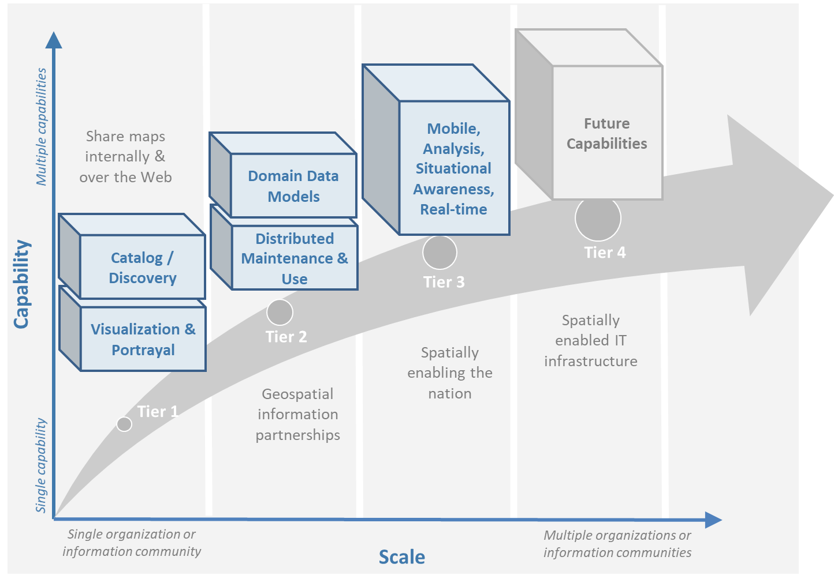

Figure 4.3 Tier 3 Capability Enabled by Standards

The development and publication of these “foundation” or “framework” spatial data such as imagery, transportation, administrative boundaries, using content and technology standards and good practices enable geospatial data from different providers to be easily integrated and used across multiple applications domains, so that decision making is based upon a common understanding.

Figure 4.4 depicts potential “foundation” geospatial information themes shared between and among many organizations and constituents.

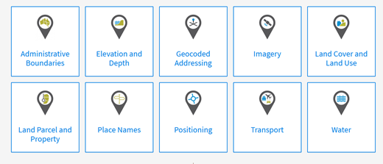

*Figure 4.4: Example: Foundation geospatial information layers (Source:* [*ANZLIC*](http://link.fsdf.org.au/)*)*

Geospatial information can be designed for delivery across multiple platforms and can be discovered, described, and accessed via web-based catalogs. Essential geospatial information themes are made available as “foundation” or “framework” data. These foundation themes have known accuracy and currency so that other geospatial data can be consistently integrated. [UN-GGIM Working Group on Global Fundamental Geospatial Data Themes](http://ggim.un.org/UNGGIM-wg2/) have developed 14 foundational data themes in support of the UN-GGIM program of work.

**Capabilities of Tier 3**

* Capabilities of Tiers 1 and 2
* Delivery of foundation or framework geospatial information for online access and download
* Geoprocessing (also known as Geo-Analytics)
* Mobile applications
* Customized Web applications
* Integration of real time sensor feeds
* Customized geographic information products.

### **Typical Scenarios**

* A nation begins the implementation of a National SDI to deliver foundational or framework geospatial data for the nation. This may be an effort that starts from scratch or builds on domain specific activities characterized in Tier 2
* Provision of geoprocessing services over the web
* Delivery to multiple platforms including desktop and mobile
* Incorporation of real time data from a variety of sensors
* Account for data sovereignty
* A robust framework of geospatial information management policies has been established for organizations operating from the local to national level. In place are:
  + Well defined geospatial data themes,
  + Data content models,
  + Policies for data access and sharing,
  + Service level agreements between organizations and governments for operations and cooperative maintenance of data themes.

Multiple organizations share foundation/framework geospatial information and services with each other and the broader community to improve knowledge and understanding, thereby contributing to evidence-based decision making, situational awareness, and improved societal outcomes.

In this Tier, the infrastructure is mature enough to support deployment of more and more applications to enhance value, provide increased citizen benefit, increase collaboration between organizations. There is also the introduction and integration of an increasing number of geospatial information resources, including volunteered and real time sensor feeds. We will also see mature deployment of mobile applications. The standards mentioned in the Tier 3 and related URLs are listed in Table 4.3.

### **Geospatial Processing & Analytics**

Processing in the most general sense means - on their way from server to client tool (and then possibly onwards to client screen) data gets modified. In a simple scenario this is already done by an [OGC WMS](http://www.ogc.org/standards/wms) when it applies “styling” to a layer. However, processing can be highly complex, such as processing to generate long-running server-side simulations. In recent years, “analytics'' has become a common term for - loosely speaking - processing done for gaining insight. Following the Big Data principle of “process data close to the source” because data are “too big to transport”, such processing tasks are preferably executed on the server that houses the data.”.

The approach for this process, which almost exclusively[23] uses the WWW http protocol, is that a client sends a request encoded as a URL (which contains the processing task, objects addressed, result formats, and any further parameters needed).

While there is general consensus on the advantages of “shipping code to data” there are a range of options on how to do this; the alternatives below are each represented by a standard, allowing service providers to pick their favorites:

* Purely RESTful approaches encode processing directives in the path component of a request URL, sometimes (such as for format encoding) also in key/value pairs in the URL. This allows requests consisting of a single-line URL, in the extreme case typed directly into a browser address line by a user savvy with the particular syntax. Obviously, this has very limited expressiveness, with little degree of freedom for the user (or client program) sending such a request.
* [*OGC Web Processing Service (WPS)*](https://www.ogc.org/standards/wps) – provides rules for standardizing how inputs and outputs (requests and responses) for geospatial processing services, such as generating a polygon overlay. [The standard also defines how a client can request the execution of a process, and how the output from the process is handled. It defines an interface that facilitates the publishing of geospatial processes and the clients’ discovery of and binding to those processes and clients’ discovery and binding to those processes, thereby establishing “syntactic interoperability”.](http://www.opengeospatial.org/standards/wps) The data required by the WPS can be delivered across a network or they can be available at the server. Processes are predefined by the administrator and users can only provide their individual input parameters. [A particular use case for WPS is making a Web service out of code that originally was not Web-ready.](http://www.opengeospatial.org/standards/wps) <http://www.opengeospatial.org/standards/wp>s.
* [*OGC Web Coverage Processing Service (WCPS)*](https://www.ogc.org/standards/wcps) - provides a [datacube analytics language](https://earthserver.xyz/wcs/#wcps) for server-side Big Earth Data processing. Without any programming, users can send any query, any time to the server for processing directly at the data source. Further it is possible to provide the user’s own parameters alongside with a query, for example to compare or combine an user’s dataset with a server-side dataset. On the administrator side there is no configuration necessary. As of this writing, multi-Petabyte Earth datacubes are [being served operationally via WCPS](https://earthserver.xyz), with location-transparent distributed datacube fusion over globally networked data centers.

OGC and EU INSPIRE have adopted [WCPS](http://www.ogc.org/standards/wcps) [OGC 08-068r2](https://external.ogc.org/twiki_public/pub/CoveragesDWG/CoveragesBigPicture/08-068r3_Web-Coverage-Processing-Service-Language_2020-08-11.pdf) as the analytics component of the WCS suite.

### **Grid Systems**

A DGGS is a spatial reference system that uses a hierarchical tessellation of cells to partition and address the globe. The [*OGC Discrete Global Grid Systems (DGGS*](http://docs.opengeospatial.org/as/15-104r5/15-104r5.html)*)* and the [*ISO 19170 Geographic Information: Core Reference System and Operations, and Equal Area Earth Reference System*](http://www.iso.org/standard/32588.html) are key standards for understanding and implementing DGGS. DGGS are characterized by the properties of their cell structure, geo-encoding, quantization strategy and associated mathematical functions. The [OGC DGGS Abstract Specification](https://docs.opengeospatial.org/as/15-104r5/15-104r5.html) supports the specification of standardized DGGS infrastructures that enable the integrated analysis of very large, multi-source, multi-resolution, multi-dimensional, distributed geospatial data. Interoperability between OGC DGGS implementations is anticipated through implementation standards, and extension interface encodings of OGC Web Services. This specification has particular benefit in the context of integrating geospatial and statistical Information and has been referenced in the [Global Statistical Spatial Framework](http://ggim.un.org/meetings/GGIM-committee/9th-Session/documents/The_GSGF.pdf).

### **Mobile Devices**

Increasingly, mobile devices are becoming a key source for geospatial data capture, maintenance, and application. These capabilities are in addition to the simple ability to display maps to a mobile device as required in Tier 1. While OGC web services standards noted above work in the mobile internet environment, we note that there are other adopted and in-work standards that may be of relevance to Tier 3:

* [*OGC Open GeoSMS*](https://www.ogc.org/standards/opengeosms) is an adopted OGC standard that defines a standard approach to encoding a geo-tag for an SMS message. *Open GeoSMS* enables mobile users to transparently send location information in the header of their mobile text messages.
* [*OGC GeoPackage*](http://www.geopackage.org/spec/) standard is an open, app-independent, platform-independent, portable, interoperable, self-describing data container and API. Designed for mobile applications, this standard is intended to support multiple mapping and geospatial applications such as fixed product distribution, local data collection, and geospatially enabled analytics.

### **Real time**

Increasingly, geospatial information is being generated as the result of real time observations being captured by in-situ and dynamic (moving) sensor systems. These information resources provide the ability to enhance decision making, situational awareness, quality of life, sustainability, and other useful functions. Anyone with a smart phone is already using or accessing real time sensor information, such as the current temperature at a particular location.

The OGC has a suite of standards that allow applications and services to describe, task, and request observations from one or more sensors. This suite of sensor standards is called [*OGC Sensor Web Enablement (SWE)*](https://www.ogc.org/node/698). The OGC uses the following definition for a sensor:  
*“An entity capable of observing a phenomenon and returning an observed value.”*

The type of observation procedure determines the estimated value of an observed property as its output. A web or internet accessible sensor is any sensor that has an IP address that can provide or be tasked to provide an observation. Sensors can be in a fixed position or mobile. An excellent example of an OGC SWE implementation is the [US NOAA Integrated Ocean Observing System (IOOS)](https://ioos.noaa.gov/). This system provides real time access to mobile and in-situ ocean observing sensor systems. These sensors are obtained from numerous different technology providers, all described, tasked, and accessed using OGC SWE standards. Other excellent examples of operational use of OGC SWE standards are:

* [Sensors Anywhere (SANY)](https://www.researchgate.net/profile/Pier-Marchetti/publication/258644058_Heterogenous_Missions_Accessibility/links/56960b3d08ae3ad8e33d9d8c/Heterogenous-Missions-Accessibility.pdf) - SANY aims to improve the interoperability of in-situ sensors and sensor networks, allowing quick and cost-efficient reuse of data and services from currently incompatible sources in future environmental risk management applications.
* The [Heterogeneous Missions Accessibility (HMA)](https://earth.esa.int/documents/1656065/1681917/TM-21.pdf) initiative aims to harmonize ground segment interface activities for Earth observation (EO) missions.

The main SWE suite of standards are:

* [*OGC/ISO Observations & Measurements Schema (O&M)*](https://www.ogc.org/standards/om) */* [*ISO 19156*](https://www.iso.org/standard/32574.html) – An OGC standard that defines conceptual models for encoding observations and measurements from a sensor, both archived and real-time.
* [*OGC Observations and Measurements XML (OMXML)*](https://portal.ogc.org/files/?artifact_id=41510) – GML/XML encoding of the abstract O&M model.
* [*OGC Sensor Model Language (SensorML)*](https://www.ogc.org/standards/sensorml) – An OGC standard that defines standard models and XML Schema for describing sensors systems and processes; provides information needed for discovery of sensors, location of sensor observations, processing of low-level sensor observations, and listing of task-able properties.
* [*OGC Sensor Observations Service (SOS)*](https://www.ogc.org/standards/sos) - An OGC standard that specifies a standard web service interface for requesting, filtering, and retrieving observations and sensor system information. This is the intermediary between a client and an observation repository or near real-time sensor channel.
* [*OGC Sensor Planning Service (SPS)*](https://www.ogc.org/standards/sps) – An OGC adopted standard that specifies standard web service interface for requesting user-driven acquisitions and observations. This is the intermediary between a client and a sensor collection management environment.

More and more SDIs are integrating real time sensor feeds. This real time information is used to enhance situational awareness or is fused with other geospatial information resources to enhance decision support. Another key use for real time sensor information is to feed modelling systems that are used to predict severe weather events, tsunamis, debris flows, and other potential catastrophic events that impact human lives.

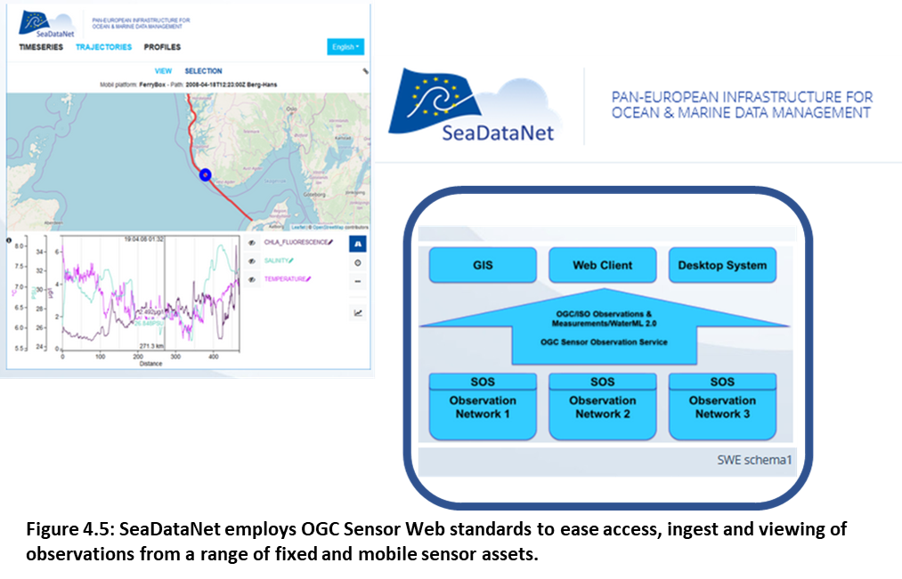

*Figure 4.5: SeaDataNet employs OGC Sensor Web standards to ease access, ingest and viewing of observations from a range of fixed and mobile sensor assets***.**

A further standard to consider is the [*OGC SensorThings API*](https://www.ogc.org/standards/sensorthings). The *OGC SensorThings API* is an OGC standard specification for providing an open and unified way to interconnect IoT devices, data, and applications over the Web. The *SensorThings API* is an open standard, builds on Web protocols and the [*OGC Sensor Web Enablement* standards](https://www.ogc.org/node/698), and applies an easy-to-use REST-like style. The result is to provide a uniform way to expose the full potential of the Internet of Things.

Notably, there is a close connection between sensor and coverage standards as they share, among others, the identical sensor semantics description. Hence, an upstream SOS service might collect and homogenize data which subsequently get stored and served as coverages by the downstream-optimized *WCS, WCPS, WMS, WPS*, and all other standards supporting coverages, without any loss of semantics.

### **GeoSemantics**

GeoSemantics means that data is explicitly defined, persistently and uniquely identified, and transferred into machine-actionable format that supports quick data interlinking, searchability, interpretation, and reuse that improves the data integration and analysis on the Web. GeoSemantics uses the web linked data pattern, and is supported by a set of standards, practices, and tools for publishing and linking structured data on the Web.

*The ISO 19150 (Geographic information – Ontology)* series of standards are developed to support semantic web. [*ISO 19150-1*](https://www.iso.org/standard/57465.html) defines the framework for semantic interoperability of geographic information. This framework defines a high-level model of the components required to handle semantics in the ISO geographic information standards through the use of ontologies.

The [Spatial Data on the Web Interest Group](https://www.w3.org/groups/ig/sdw) (W3C/OGC) is one of the communities that is providing significant input to development of good practices and vocabularies that encourage better sharing of spatial data on the Web; and identify areas where standards should be developed jointly by both W3C, OGC and ISO, including [*OGC GeoSPARQL*](http://www.ogc.org/standards/geosparql)and [*ISO 19150*](http://www.iso.org/standard/57465.html).

|  |  |
| --- | --- |
| **Technology in Tier3** | **Relevant Standard** |
| Geospatial Processing & Analytics | OGC Web Processing Service (WPS) |
| OGC GroundWaterML |
| Grid Systems | OGC Discrete Global Grid Systems (DGGS) |
| Mobile Devices | OGC Open GeoSMS |
| OGC GeoPackage |
| Real Time | OGC/ISO Observations & Measurements Schema (O&M) / ISO 19156 |
| OGC Observations and Measurements XML (OMXML) |
| OGC Sensor Model Language (SensorML) |
| OGC Sensor Observations Service (SOS) |
| OGC Sensor Planning Service (SPS) |
| OGC SWE Common Data Model Encoding Standard |
| OGC SWE Service Model Implementation Standard |
| OGC SensorThings API |
| OGC Moving Features |
| GeoSemantics | ISO 19150-1 Geographic information – Ontology (Part 1: Framework) |
| ISO 19150-2 Geographic information – Ontology (Part 2: Rules for developing ontologies in the Web Ontology Language (OWL)) |
| ISO 19150-4 Geographic information – Ontology (Part 4: Service ontology) |
| OGC GeoSPARQL |
| W3C Semantic Sensor Network Ontology |

*Table 4.3 Standards in Tier 3, for standard descriptions see* [*Appendix 1*](https://drive.google.com/file/d/1DAb4QinqlEecqFzvtqi7JpnX7zzpdZJM/view?usp=sharing)*.*

## **Tier 4 – Future Capabilities: Spatial Data Integrated with Global Data Ecosystem**

This document has identified the levels of capability that are enabled by geospatial information and the associated technologies and standards that make up a mature local to global SDI. Through the adoption of standards, increasing levels of interoperability can be achieved, with geospatial information becoming more easily accessed, managed, shared, and used for improved situational awareness and decision making. Through use of core standards recommended in this document, the decision to share becomes a policy decision, uninhibited by technological limitations of geospatial information incompatibility issues.

With the rapid pace of technological advancement and the emergence of new data sources and innovative practices, we are seeing the integration of location data and resources in an ever expanding “Geospatial Web”.

Organizational policies, standards, and associated good practices will need to evolve to make it easier to apply these new technologies, information sources and processes. This evolution should also be implemented in the more general context of the importance of geospatial information management to international sustainable development goals as discussed in [Monitoring Sustainable Development Contribution of Geospatial Information to the Rio+20 Processes](http://ggim.un.org/knowledgebase/Attachment2200.aspx?AttachmentType=1).

Figure 4.6 implies a point in the future when a geospatial infrastructure will be complete or fully realized. The reality, however, is that the market is delivering technology advancements on a continual basis. Many of these advancements will help to further improve organizational decision making and reduce cost and effort associated with IT infrastructure. Organizational leadership must be prepared to take advantage of key technology advancements when they become widely available.

To take advantage of these trends we recommend that appropriate organizational staff:



*Figure 4.6: Future capabilities will be mobilized more quickly via standards*

* Leverage the global resources of groups such as the UN-GGIM, SDOs, and other major associations mentioned in this document to identify trends, and to adopt good practices.
* Participate in standards development work of OGC, ISO/TC 211 and IHO to understand implications and assure earliest implementation of standards that will help ease integration of new technologies. At a minimum, organizations and institutions should consider providing their interoperability requirements to the OGC, ISO, and/or IHO. This does not require much time but ensures that these requirements are documented and considered in the ongoing development of international standards.

### **Standards in Tier 4**

As our global web of information continues to increase with both data and technology, our capacity to share geospatial data increases towards becoming a spatially enabled web of data.

For general understanding of the industry trends the reader is referred to the UN-GGIM report, “[Future Trends in geospatial information management: five to ten year vision](https://ggim.un.org/meetings/GGIM-committee/10th-Session/documents/Future_Trends_Report_THIRD_EDITION_digital_accessible.pdf)” for details on what we believe to be the technological, legal, policy, and consumer trends impacting the collection, use, and visualization of geospatial information.

To assist in understanding these trends in a geospatial standards context, the OGC has worked with its membership, alliance partners and others to develop and maintain the [OGC Technology Trends](http://www.ogc.org/OGCTechTrends). This research informs the road-mapping for standards development, thus ensuring that necessary standards are developed at pace with technology development.

These trends are driving requirements for enhancing existing geospatial standards, rethinking and crafting a new generation of standards based on the lessons learned of the existing baseline, and incorporating new suites of standards required to leverage the value of the emerging technologies and user requirements.

There could be several different views on the trends driving new areas of standards development or new applications of existing standards. One of many such views, which combine the UN-GGIM and OGC’s trends, is presented below (Fig. 4.7): 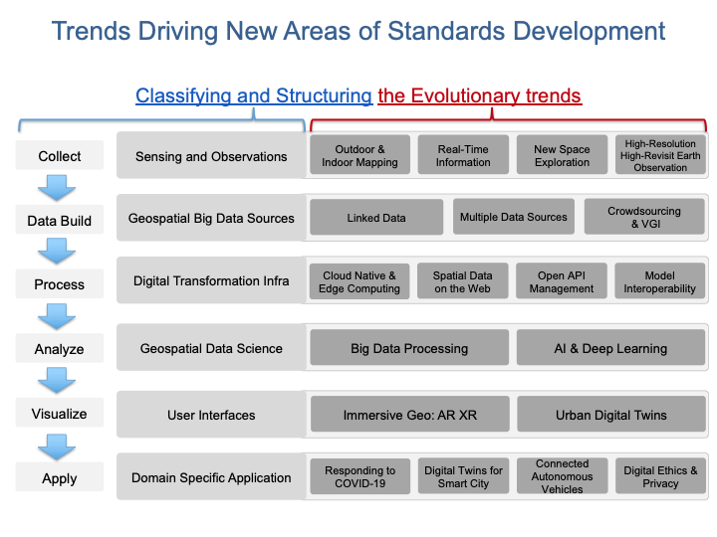

|  |
| --- |
| *Figure 4.7. Trends driving New Areas of Standards Development* |

The following are a few of the trends driving new areas of standards development or new applications of existing standards as they are listed in Figure 4.6. The standards mentioned in Tier 4 along with related SDOs (Standard Development Organizations) are listed in Table 4.4.

**Sensing and Observations**

* **Outdoor & Indoor Mapping** – Through the convergence of Geographic Information System (GIS) and Building Information Modelling (BIM), seamless experience between outdoor and indoor mappingbecomes an expectation. GIS and BIM will likely converge as users are increasingly expecting a seamless experience between indoor and outdoor mapping. In addition, over the long-term, 5G could be used to augment positioning services as low latency may use the time difference of arrival between sending and receiving antennas. Using the geometry of the antennas will make it possible to calculate the angle from which the signal arrives and as the number of measurements increase an accuracy of 5 centimeters or better can be expected. The main barrier yet to overcome is the need for investment in 5G infrastructure to obtain complete coverage. GNSS and 5G in combination and GIS-BIM interoperability may also prove very effective for seamless indoor and outdoor positioning and mapping.
* **Real-Time Information** – Today, sensor networks are increasingly common in cities providing near real-time information on temperature, moisture, noise, and pollution levels, enhancing efficiencies and enabling data-driven decision-making by both public and private stakeholders. Real-time information applications already assist many municipalities in their decision-making processes and there is an ever-growing need for status updates on one or more devices to be as timely as possible. As digitalization improves, real-time information will assist more organizations in their everyday processes, particularly those responding to emergency events, such as disasters and disease outbreaks. The ability for smart city services to be built upon high quality geospatial base data which is required to plan, build, operate and maintain assets will enable many future high value services to be developed to enable smart cities.
* **New Space Exploration** – Technological advances in Earth observation have created a step change in the quality, accuracy, and precision available which makes it possible to map from space with ever increasing resolution worldwide.
* **High-Resolution High-Revisit Earth Observation** –The increasing availability of high-resolution satellite imagery has transformed remote sensing by improving accessibility and frequency of updates; thus, enabling better evidence-based decision-making and service delivery. In several countries, the seasonality of water features plays a crucial role. Enhanced with the combined use of SAR data, high-resolution imagery that provides insight into water flows and water levels are increasingly utilized. The currently under-exploited high-resolution high-revisit imagery sources are expected to become more widely used and have the potential to become a valid alternative to aerial imagery. Yet, at the moment, there are only few globally consistent sources of high-resolution high-revisit data. For nations to see the benefits of these developments, the cost of purchasing will have to decrease and/or access will need to be broadened.

### **Geospatial Big Data Sources**

* **Datacubes** - this concept, defined in the ISO/OGC/INSPIRE Coverage standards, unifies gridded (“raster”) data offering several critical advantages:
  + Datacubes work across all dimensions using all the same handling for Latitude, Longitude, height, depth, time, etc. In particular, combining data across dimensions (such as 2D DEMs, 3D x/y/t image timeseries and 4D x/y/z/t climate data) gets simple and well-defined.
  + Datacubes serve to homogenize the millions of “scenes” (i.e., sensor-oriented representations) into very few datacubes (i.e., user-oriented representations), such as just one single cube for every Landsat, Sentinel, etc. instrument.
  + The powerful concepts of the OGC Coverage data model allow modelling of any grid situation, including any number of dimensions, regular and irregular axes (such as regular Lat/Long orthoimages plus an irregular timeseries), and with encodings in a series of formats ranging from *XML*, *JSON*, and *RDF* over *JPEG2000* to *OGC NetCDF*.
  + As such, datacubes are an accepted cornerstone towards Analysis-Ready Data (ARD), a vision of liberating users from all the hassle of data wrangling allowing them to concentrate on gaining insight from Big Data.
  + Suitable services, such as the “actionable datacubes” provided by the [*OGC WCPS*](http://www.ogc.org/standards/wcps) datacube analytics language, allow any query at any time in a fast and simple manner; in practice, such *WCPS* queries today often are generated automatically from clients doing visualization (such as QGIS, WorldWind or Cesium) or analytics (such as Jupyter notebooks or numpy).
* **Linked Data** – The concept often related to Big Data (see also below under “Geospatial Data Science”) and other newer sources of geospatial content is “linked data”. Linked data is a concept related to the semantic web. From W3C, “The Semantic Web isn't just about putting data on the web. It is about making links, so that a person or machine can explore the web of data. With linked data, when you have some of it, you can find other, related, data.” Wikipedia defines Linked Data as "a term used to describe a recommended best practice for exposing, sharing, and connecting pieces of data, information, and knowledge on the Semantic Web using URIs and RDF.".
* **Multiple Data sources** – A Digital Twin is a digital representation of a physical asset that enables users to visualize it, check the asset’s status, perform analysis, and generate insights to predict and optimize its performance. In comparison to static 3D models, Digital Twins are directly linked to **multiple data sources** and receive updates continuously.
* **Crowdsourcing & Volunteered Geographic Information** – Geo Crowdsourcing includes social media and VGI**.** Crowdsourcing refers to the process of obtaining geo inspired services, ideas, or content by soliciting contributions from a large group of people, especially an online community, rather than from employees or suppliers. Land administration in developing countries can benefit from **Crowdsourcing and VGI** as missing and outdated authoritative land and tenure information are often due to the lack of human, budgetary or other resources. However, questions around quality continue to hold back the wider uptake of crowdsourced information by public bodies of developed countries. Still, as technology matures and new possibilities arise, new processes and algorithms continue to be developed with the aim that data sources will comply with the same standards and quality that is expected of authoritative data.

### **Digital Transformation Infrastructure**

● **Cloud Native & Edge Computing** – Cloud computing and the internet have transformed the way in which organizations manage data. It has been designed to treat IT as a scalable service that can increase or decrease capacity to match user demands, leverage shared technologies and Open API hardware, and ultimately realize economies of scale. Edge computing enables reliability, mitigates risk, and facilitates situational awareness of autonomous systems. For instance, edge computing is set to provide faster access to information with IoT enabled devices, such as autonomous vehicles, drones, and sensors. When combined with the Semantic Web, edge computing will interconnect the physical and information technology world by simultaneously generating and harvesting spatial data and producing this data in a format that can be queried by both humans and computers to deliver new information; thus, providing knowledge-on-demand.

● **Spatial Data on the Web** – OGC and the W3C are working together to advise on good practices for the publication of spatial data on the Web, based on the Semantic Web´s concept of Linked Data. Spatial Data on the Web Best Practice is a joint document between the OGC and the W3C that identifies good practices for publishing spatial data on the Web.

● **Open API Management** – Interoperability, accessibility, and discoverability of data – via data portals, application programming interfaces (APIs), and linked identifiers – will enable effective data use. The explosive growth of public APIs for geospatial applications, and the accompanying variability in API practices across the IT industry, as well as in geospatial APIs specifically, has created new opportunities and challenges in supporting geospatial services. This development will transform the *OGC WPS* into Open API-Processes, resulting in syntax designed for that and the administrators will have to build some *YAML* configuration files as well as *JSON* data structures for processes that can be invoked subsequently. In the OGC Open API initiative there is an ongoing development of a specification aimed at these types of services. The plan is likely to be adopted in 2022/2023 (depending on each component). For greater understanding in this area visit [OGC Open APIs – Building Blocks for Location](https://ogcapi.ogc.org/).

● **Model Interoperability** – Relevance of data integration and interoperability increase. An OGC White Paper (Data Models and Interoperability) provides an excellent discussion on establishing agreed upon data models for data sharing and enhancing interoperability.

### **Geospatial Data Science**

● **Big Data Processing** – Big data processing has become a normal path of geospatial data processing. It will be the norm as machine learning and deep learning mature and become established functions in geospatial production. In order to properly address many sustainability issues, the world of big science needs to be fused with the SDI and Earth Observation communities. Some of this collaboration and fusion is happening in the Open Geospatial Consortium in the Meteorology, Hydrology, and Emergency and Disaster Management Working Groups. These working groups are defining good practices for integrating domain specific observations, modeling, and scientific research into current and future information infrastructures using existing standards. The foundational data and service models are being developed and advanced by the Coverages Working Group. (See also the section on Processing and Analytics above.)

● **AI & Deep Learning** – Machine learning, deep learning and Artificial Intelligence have established themselves as disruptive forces within the geospatial domain. Although pure Artificial Intelligence is still in the research stage, several sources have highlighted that coding has a level of bias because of which Artificial Intelligence systems need to be built by a diverse team. Given that Artificial Intelligence, statistics and geospatial are coming together rapidly and being promoted as the next ‘big thing’ to enable evidence-based decision making and policy delivery, it is crucial that diversity within all types of teams is high on the technology agenda.

### **User Interfaces**

●  **Immersive Geo: AR XR** – Visualizations and immersive technology widely used to enhance customer experience and decision making. New immersive technologies are revolutionizing the way in which users interact with digital information by enabling real-time 3D representations and immersing the user in digitally generated or enhanced realities. The technologies enable the user to interact with simulations and visually relate to the information sensors provide. The combination of geospatial data, virtual reality software and other datasets makes it possible to experience a built environment before it has been constructed. As advances towards creating Digital Twins are made, this new functionality will likely enable a virtual representation of a place or building that can be navigated via a VR headset.

● **Urban Digital Twins** – With concepts such as the “Digital Twin” for our world increase in interest and popularity, so too does the need for richer and more detailed 3D models to assist us in understanding the world around us. This area covers a broad range of tasks including 3D Computer graphics and 3D Modelling. The concept of the city Digital Twin is progressing rapidly, and it is almost impossible for effective urban planning to take place without the availability of sensors, image capture and processing, and data analysis technology. Essentially, a Digital Twin is a digital representation of a physical asset that enables users to visualize it, check the asset’s status, perform analysis, and generate insights to predict and optimize its performance. Digital Twins are set to enable an asset-centric approach helping to model, simulate and predict the performance of assets, systems, and processes within the urban environment and when fully integrated should provide autonomous operations and maintenance. Described as the highest form of Digital Twin maturity, the technology will enable complete self-governance and offer transparency by minimizing cost, lowering environmental impact, reducing operational risk, and improving operational reliability.

### **Domain Specific Applications**

● **Responding to COVID-19** – Recent emergency incidents, such as the global Covid-19 pandemic, have significantly prompted large scale projects aiming to improve the availability, quality, and accessibility of geospatial data in support of sustainable development.

● **Digital Twins for Smart Cities** – Viable integrated Digital Twins for Smart City solutions is becoming widespread. City municipalities have emerged as a highly engaged user of geospatial information, particularly since the rise of smart city solutions and Digital Twin technology have become available. Early examples of digital representations of city infrastructure have enabled municipalities to monitor and simulate scenarios related to climate change and flooding events while mitigating risks and increasing infrastructure resilience. This focus on the urban environment will continue to drive the development of viable integrated smart city solutions across the world.

● **Connected Autonomous Vehicles (CAVs)** – Trusted geospatial data enables the acceleration of the development, deployment, and safety of CAVs. Location data for planning and testing in a synthetic environment also provides geo-referencing in places where full connectivity and sensor feeds cannot be guaranteed. By the end of the 2020s, it is anticipated that the sensor technology inherent in CAVs will be sufficient to operate independently. When connected to other vehicles (V2V), to infrastructure (V2I), or to the surrounding ‘smart’ environment (V2X), CAVs may not require any additional location data to safely navigate on public roads.

● **Digital Ethics & Privacy** – Advances in how data is used and the deployment of emerging technology puts increasing pressure on understanding, anticipating, and responding to emerging ethical issues. The use of geospatial information poses serious ethical questions related to privacy, accuracy, and accessibility. Ethics related to geospatial information management focuses on the relationship between the creation, organization, dissemination, and use of geospatial data and services, and the ethical standards and moral codes governing human conduct in society. Government, business, and individuals can equally be affected by cyber-attacks leading to infringements of privacy, disruption of services, and national security risks. The advent of autonomous vehicles represents a significant source for cyber threats as the vehicles will be connected to networks such as the internet. Without cybersecurity, the ability to exploit the increasing availability of data and the rapid technological advancements will be at increased risk.

|  |  |  |
| --- | --- | --- |
| **Technology in Tier4** | | **Relevant Standard or Relevant Standard Developing Organization WG** |
| Sensing and Observations | Outdoor & Indoor Mapping | OGC IndoorGML |
| OGC CityGML |
| OGC IMDF |
| **ISO/TC 59/SC 13/JWG 14 "Joint ISO/TC 59/SC 13 - ISO/TC 211 WG: GIS-BIM interoperability"** |
| Real-Time Information | OGC Moving Features |
| New Space Exploration | OGC/ISO Coverage Implementation Schema (CIS) and OGC Web Coverage Service (WCS) |
|  | [General Bathymetric Chart of the Oceans](https://www.gebco.net/) (GEBCO) |
|  | High-Resolution High-Revisit Earth Observation | **IEEE Geoscience and Remote Sensing Society - SAR - Working Group for SAR Metadata Content Standard**  OGC/ISO Coverage Implementation Schema (CIS) and OGC Web Coverage Service (WCS)- |
| Geospatial Big Data Sources | Linked Data | W3C Resource Description Framework (RDF) |
| OGC GeoSPARQL |
| W3C Time Ontology in OWL |
| Multiple Data Sources | OGC Web Coverage Processing Service (WCPS)- |
| Crowdsourcing & VGI | OGC LandInfra / InfraGML |
| Digital Transformation Infra | Cloud Native & Edge Computing | ISO/IEC TR 23188:2020 |
| **ITU-T Study Group 13 "Future networks, with focus on**  **IMT-2020, cloud computing and trusted network infrastructure"** |
| Spatial Data on the Web | **W3C Spatial Data on the Web Interest Group** |
| OGC Web Processing Service |
| OGC Web Map Service |
| OGC Web Coverage Processing Service |
| Open API Management | OGC API - Features |
| GeoAPI Implementation Specification |
| OGC API - Features - Part 3: Filtering and the Common Query Language |
| Model Interoperability | ISO/IEC19763-1:2015 (Metamodel framework for interoperability) (MFI) family of standards |
| Geospatial Data Science | Big Data Processing | OGC Hierarchical Data Format Version 5 (HDF5) Standard |
| AI & Deep Learning | **ISO/IEC JTC1/SC 42 "Artificial intelligence"** |
| Y.3172, Architectural framework for machine learning in future networks including IMT-2020 |
| Information technology — Artificial Intelligence (AI) — Bias in AI systems and AI aided decision making |
| User Interfaces | Immersive Geo: AR XR | OGC Augmented Reality Markup Language 2.0 (ARML 2.0) |
| Urban Digital Twins | OGC CityGML |

*Table 4.4. Standards in Tier 4 (for standard descriptions see* [*Appendix 1*](https://drive.google.com/file/d/1DAb4QinqlEecqFzvtqi7JpnX7zzpdZJM/view?usp=sharing)*)*

# **Ongoing Management**

|  |
| --- |
| The purpose of this section is enabling the reader to:   * Authorize and resource a standards maintenance process essential for maintaining an effective national geospatial information management and sharing environment. * Understand how to remain current with advancements in standards through periodic review with standards bodies and communities of practice. * Discuss, identify, and submit requirements for standards to address interoperability issues through standards bodies at the organizational, national, and international levels. * Understand how they can share experiences and standards success stories with others. |

This section is intended for people who are responsible for systems and applications that implement open standards. The systems might be server applications offering standardized interfaces or client applications that consume a standardized interface. The system might also produce or consume data that conforms to one or more data standards. This section focuses on three key areas of value that can have positive impact to ongoing geospatial information management by keeping systems and solutions cost effective and adaptive to change:

* Establishing and participating in a ***Standards Review Program*** to maintain currency with new and emerging geospatial standards.
* Engaging with ***Communities of Practice (COP)*** to share experiences and benefit from success stories and lessons learned by other community members that are implementing standards-based solutions.

## **Standards Review Program**

A standards review program is a plan and process for implementing new and maintaining existing standards. SDOs typically have a form of standards review program, which over time leads to new standards and improvements to existing standards.

New and improved standards are driven by user community requirements. This is a reason for engaging with the standardization process. There may be opportunities for users and implementers of standards to engage and ensure that their requirements are captured in the standardization process, and those participating in standards review can serve as effective intermediaries between the user and standards bodies to ensure that requirements are properly articulated and addressed. Furthermore, SDOs may periodically update existing standards to address extended capabilities or to correct issues, or to provide additional guidance on implementation.

The standardization landscape also changes as technology and software development methods change. The [OGC API modernization](http://ogcapi.ogc.org/) activity, for example, is aimed in part at adapting the existing OGC Web Services (OWS) standards to the current application development environment. OGC APIs will propose (but not mandate) the use of OpenAPI for describing API endpoints. This should improve the ease with which client applications can be created to use APIs. The OGC APIs will also be compatible with existing OWS standards.

International open standards may evolve from wide-scale implementation of proprietary specifications. Increasingly, organizations are submitting these *de facto* standards to SDOs to be formally endorsed as Community standards or for consideration as international open standards. From an OGC perspective, Community standards can serve two purposes, to:

* Bring de facto standards from the larger geospatial community to be a stable reference point that can normatively referenced by governments and other organizations.
* Bring new, but implemented, standards to the OGC to form the basis for further refinement and development of interoperability between other OGC standards.[24]

The [*OGC Indexed 3D Scene Layers (I3S*](http://www.ogc.org/standards/i3s)*)* and [*OGC 3DTiles*](http://www.ogc.org/standards/3DTiles)standards submitted by OGC industry members followed this route. For a list of OGC Community Standards, visit [www.ogc.org/standards/community](http://www.ogc.org/standards/community)

As changes to standards will likely occur during the lifecycle of a system, it is important that persons responsible for planning, acquisition and maintenance of systems are aware of these changes. Several nations have in place comprehensive standards review programs which monitor the standards environment and recommend / endorse new and updated standards to keep pace with new community needs and key information and technology market advancements. It is recommended to keep up-to-date with and align to the relevant national standards review programs and even consider becoming involved in the standardization process if the relevant review program invites participation from organizations as stakeholders.

Examples of national and supranational bodies responsible for standards review programs are:

* FGDC Standards Working Group (US) <https://www.fgdc.gov/standards/organization/FGDC-SWG/index_html>
* Geonovum (the Netherlands) <https://www.geonovum.nl/> with membership of Forum Standaardisatie <https://forumstandaardisatie.nl/>
* GeoConnections (Canada) <https://www.nrcan.gc.ca/science-data/science-research/earth-sciences/geomatics/canadas-spatial-data-infrastructure/10783>
* National System of Statistical and Geographical Information (Sistema Nacional de Informacion Estadistica y Geográfica - SNIEG) (INEGI-Mexico)

[www.](http://www.)snieg.mx/scn-acerca-de/

* INSPIRE (European Union) <https://inspire.ec.europa.eu/> Community Forum <https://inspire.ec.europa.eu/inspire-helpdesk>

## **Communities of Practice**

An effective approach for ongoing management of systems and solutions that implement open standards is to network with representatives from other organizations at the national and international levels. By sharing experiences in implementing standards-based geospatial information management capabilities, organizations benefit from the successes and lessons learned by others. The SDO community engages with a range of Communities of Practice (CoP) such as Aviation, Agriculture, Energy and Utilities, Marine, Earth Systems, and Land Administration. These and other CoPs participate in OGC, ISO/TC 211 and IHO as well as in professional associations to align to a common set of standards and good practices for information sharing.

For example, there are international programs working to bring together the world’s national geological surveys and soils organizations as CoPs in order to agree on a common, federated approach for sharing globally the vital information these organizations produce and maintain at the national level.

[**One Geology**](http://www.onegeology.org) is an association that brings together national geological surveys and cooperating international organizations to address its mission to ‘**Make web-accessible the best available geological and other geoscience data worldwide at the best possible scales, starting with at least 1:1 million scale.'** National geologic data is integrated over an area of interest and made available over the web based on a well-documented OGC web services standards architecture**[25]**.

Similarly,[**The Global Soils Information System (GLOSIS)**](http://www.fao.org/global-soil-partnership/areas-of-work/soil-information-and-data/en/), part of the UN Food and Agriculture Organization Global Soil Partnership, employs OGC web services to connect national soils data for access through a common web services framework.

Many CoPs exist at the national level to facilitate communication, develop good practice documentation and guidelines, and often act as a conduit between global CoP and/or Standards Organizations.

[**The Australian Research Data Commons (ARDC)**](http://ardc.edu.au/) is a transformational initiative that enables Australian research community and industry access to nationally significant, leading edge data intensive eInfrastructure, platforms, skills, and collections of high-quality data. The ARDC facilitates the work of many CoPs as a platform for information exchange, good practice advancement, problem solving and peer support. htps://ardc.edu.au/resources/communities-of-practice/

[**Earth Science Information Partners** (**ESIP**)](https://www.esipfed.org/) is a community of data and [information technology](https://en.wikipedia.org/wiki/Information_technology) practitioners that come together to coordinate Earth science [interoperability](https://en.wikipedia.org/wiki/Interoperability) efforts. ESIP enables and supports high quality virtual and in-person collaborations amongst cross-domain data professionals on common data challenges and opportunities (<https://www.esipfed.org/get-involved/collaborate>).

Another important example is illustrated in the power of integrating statistical and geospatial information for the production and dissemination of location relevant statistics. The integration includes geocoding of statistics, spatial analysis, and creating statistical maps. Several governmental bodies are responsible for supporting the integration of statistical and geospatial information, and provide

* As the coordinating body of Mexico's National System of Statistical and Geographic Information (SNIEG), INEGI issues and provides the technical regulations for coordination and integration of statistical and geographical information. The [National Geostatistical Framework](https://en.www.inegi.org.mx/temas/mg/) of Mexico drives Mexico’s national housing inventory, delineation of metropolitan areas and human settlements, school census data, and economic units among other entities.
* Within Eurostat, the Geographical Information System of the Commission (GISCO) is for improvement of the integration of statistical and geospatial information at the EU level. It seeks to promote the use of geographical information and the GIS within the European Statistical System (ESS) and the EU-Commission (see: <https://ec.europa.eu/eurostat/web/gisco>).

Eurostat and Mexico along with many other nations are heavily involved as a CoP in the activities of UN-GGIM, with focus on advancing a [Global Statistical Geospatial Information Framework documen](http://ggim.un.org/meetings/GGIM-committee/9th-Session/documents/The_GSGF.pdf)t.

The technical documents and insight offered by these and other CoPs can be of great value to organizations seeking to manage services that are interoperable within the organization and across organizations from the local to international level.

[Appendix 7](https://drive.google.com/file/d/14cmwQxcbrvTxxW1YspsbFOrM5R36zFnu/view?usp=sharing) summarizes some of the key CoPs represented in the OGC, ISO/TC 211 and IHO, along with references to various professional associations that can be an excellent resource for gaining understanding of current and emerging community requirements for data sharing, exchanging community implementation good practices and lessons learned, and in identifying new standards needs and opportunities. In addition to a range of user-community oriented CoPs, the table also includes CoPs that bring together expertise on key geospatial technology areas such as Sensors and IoT, Artificial Intelligence and Machine Learning. These communities offer additional opportunities to learn about emerging standards-based technologies that may have benefit to an organization.

# **Achieving Outcomes**

|  |
| --- |
| The purpose of this section is enabling the reader to:   * Understand the importance of how standards will improve sharing and use of geospatial information and optimize geospatial information management. * Understand use cases to apply rapid mobilization of new sources of data and technologies and avoid lock-in to specific technology providers. * Understand requirements for improved uptake of geospatial information across government and with the private sector and citizens; and creating efficiencies in geospatial data production and lifecycle management, saving effort, time, and cost in reusing and repurposing data. * Understand the benefit realization and compliance of standards with the development of indicators to assess, monitor and evaluate as part of an internal/external auditing exercise. |

## **Putting it all together**

In a perfect world, reading this Guide once would result in a fully informed computer mapping expert. However, the authors will be the first to inform the reader that the path over time is filled with challenges, failures, and victories. Through an iterative process of discovery, and re-discovery, geospatial experts learn, and re-learn, what it takes to achieve a successful outcome. Implementations are often followed by re-imaginations of what works best in a given situation, which often changes by the time everyone comes on board with their efforts and discover what their role should be.

As a result, please consider that each situation is unique, and one must often scramble to make all of the pieces fit. Frustrating, yet normal and expected. Many of the pieces are included above, with the expectation that many readers will be thinking that some aspects do not apply to their situation. However, it is good to know what else is out there, so that one will know to go looking for it when needed, knowing that it exists to be found.

That said, the details of geospatial standards provide the most comprehensive knowledge guideline. They define how everything actually works and fits together to function properly. If one knows how a computer file is structured, or data delivered over a network, or an interface displayed, one can know what to look for when it doesn't function as expected. Many computer experts most often find themselves asking why something doesn't work, and marvel at their good fortune when it does.

Three main aspects of positive outcomes are compliance, success indicators, and role models of success.

## **Compliance**

A system of compliance is encouraged to ensure that organizations are implementing the nationally (or internationally) endorsed standards that promote data sharing and use, and to verify that technology products and services acquired by government properly implement the required standards. There are four aspects levels of standards compliance that should be considered:

1. Starting from the beginning, the goal is to achieve regular assessment and validation of organizational compliance in implementing endorsed standards in geospatial information management activities that align with agency, regional and national policy.

2. One main method is the inclusion of nationally endorsed geospatial information management standards as a requirement for all organizational procurements/tenders delivering geospatial technologies and data products and services, with a mandate or preference for delivery of products and services that have been tested and certified as compliant (where such compliance tests are available) with the standard by the appropriate compliance authority.

3. Agency, regional and national policy should include the facilitation of testing and certification functions which can provide formal certification nationally as well as certification recognition under international testing and certification standards, frameworks, and conventions (see <https://github.com/opengeospatial/cite/wiki>.

4. Use of available technology compliance testing resources to confirm proper implementation of standards related to any government developed technologies. SDOs ISO geospatial standards include self-evaluation resources that can be useful. OGC offers freely accessible and offers on-line test procedures and manages certifications.

The [OGC Compliance Interoperability Test Engine](http://cite.opengeospatial.org/teamengine/) and ISO 19105 test scripts are available as open source technology, and can be implemented by government organizations for testing of internal government systems which use, or may have been modified to use OGC and ISO standards.

The ISO 19105 standard specifies the framework, concepts and methodology for conformance testing and criteria to be achieved to claim conformance to the family of applicable standards documents regarding geographic information and relevant application domains. It provides a framework for specifying abstract test suites (ATS) composed of abstract test cases grouped in conformance classes and for defining the procedures to be followed during conformance testing. ATS for each individual ISO/TC 211 standard is found in their respective Annex A. Conformance may be claimed for data or software products or services or by specifications including any profile or functional standard.

A Use case for using ISO 19105 and the Abstract test suites for is found <an external link or reference to the appropriate annex/part of this Guide>

IHO has a long history of supporting international testing frameworks for certification against global standards supporting the SOLAS convention. These testing and compliance regimes are the result of global harmonization efforts by many national agencies (see: [Standards in Force | IHO](https://iho.int/en/standards-in-force))

## **Success Indicators**

It is important to have a Benefits Realization Plan and establish success indicators to gauge whether benefits have been realized. Success indicators typically set targets and define how the benefits will be measured, and what evidence will be used as the basis. It is valuable to know when the objective of implementing standards has achieved overarching goal(s), such as enhanced interoperability and data integration.

The benefits of implementing a common standards framework are achieved over time and reinforce the need for a national standards strategy for verifying that implementations had the desired impact in reaching overarching goals and objectives. By implementing geospatial information management systems based on a common, open, standards framework, technological barriers to geospatial information sharing can be significantly minimized.

This allows the decision to share geospatial information among organizations from the local to global level, to be one of policies; regarding open data, as well as data that should be restricted from sharing due to clearly defined privacy or security policies. Without a common standards framework, organizations risk creating technical barriers to data sharing and locking their organizations into a particular technology solution.

When data sharing becomes a requirement in such an environment, costly and time-consuming custom software development is often required to solve data compatibility challenges – raising system lifecycle costs, and more importantly, causing missed opportunities to share and cooperate on urgent, time sensitive issues.

By adopting and implementing a common geospatial information management standards framework across government and with other stakeholders, governments can better assure that geospatial information managed by different organizations can be discovered, accessed, and applied to address a range of important issues. Organizations reduce their IT lifecycle costs and make it easier to add new standards-based capabilities as they are offered by industry.

They also take advantage of the interoperability enabled by the variety of geospatial and IT products and services available on the market that implement these standards, as well as case studies from the user community that illustrate the benefits of adopting international geospatial standards, such as those summarized in this Guide and Appendix 7 Other indicators may include assessing, monitoring and evaluating as part of an internal/external auditing exercise, and may include factors such as:

* Improvements in geospatial data production and management efficiencies that save time and effort.
* Improved ability to share geospatial information with ease under normal operational and urgent situations.
* Cost savings related to the reuse / repurposing of geospatial data.

Examples of Community good practices are provided in IGIF Appendix 6.7. See Interrelated Action for a Benefits Realization Plan (SP3).

## **Standards Training, Tools and Related Resources**

A range of training, references and tools are made freely available by the SDOs and other organizations committed to advancing efficient and effective geospatial information management. A few examples are provided below. Readers are encouraged to refer to [Appendix 8](https://docs.google.com/spreadsheets/d/1fr_qnz47EsDbHyaZatwdHS940QBm4b9nXT7erVg1-nk/edit?usp=sharing) for a detailed listing of training, tools and other resources.

### **Education / Training**

The following are examples online and freely available education and training programs. Please refer to [Appendix 8](https://docs.google.com/spreadsheets/d/1P9KDa5sts9iH91GXA_lFs-Y2RmvsqACirevFA12460c/edit?usp=sharing) for additional details on training.

* OGC eLearning modules to understand and implement standards, [Understanding OGC Standards — OGC e-Learning 2.0.0 documentation (opengeospatial.github.io)](http://opengeospatial.github.io/e-learning/ogc-standards/text/services-ogc.html)
* European INSPIRE Training Library: <https://inspire.ec.europa.eu/portfolio/training-library>
* The ANZLIC Intergovernmental Committee on Surveying and Mapping (ICSM) Metadata Working Group has created a video:  [Metadata: What is it, and why is it so important?](https://sho.co/1C95Q)
* There are a wide range of FAIR data training resources and courses offered on the internet and by various organizations worldwide. One such example is provided by the [Australian Research Data Commons](http://ardc.edu.au/resources/working-with-data/fair-data/fair-data-training/):
* ESIP provides a comprehensive set of training and tools. <http://dmtclearinghouse.esipfed.org/>
* [Introductory AusPIX DGGS Video](https://locationindex.s3-ap-southeast-2.amazonaws.com/DGGS.mp4)
* [Metadata: What is it, and why is it so important?](https://sho.co/1C95Q)

### **Strategic Goals and Planning**

IGIF SP1, Strategic Pathway 1 - Governance and Institutions, provides guidance on strategic planning. Since standards are a fundamental aspect of achieving appropriate outcomes, it can be useful to ensure that local strategic plans incorporate standards at the earliest stages. Examples of Strategic Plans:

Examples of Strategic Plans:

* UK Geospatial Commission: [UK Geospatial Strategy](http://www.gov.uk/government/publications/unlocking-the-power-of-locationthe-uks-geospatial-strategy)
* US NSDI Strategic Plan
* ISO defined 2030 as a milestone to reflect on our progress and evaluate our fundamental work as an organization. This time frame aligns with the UN’s ambitious Global Agenda for 2030, which, as outlined through the 17 Sustainable Development Goals, will require international collaborative effort to become a reality. See: [ISO Strategy 2030](https://www.iso.org/files/live/sites/isoorg/files/store/en/PUB100364.pdf)
* [ANZLIC Strategy that aligns with and supports global and domestic initiatives.](https://www.iso.org/files/live/sites/isoorg/files/store/en/PUB100364.pdf) <https://www.anzlic.gov.au/anzlic-council/anzlic-strategic-plan-2020-24>
* Global Earth Observation System of Systems (GEOSS) developed a strategic plan:https://earthobservations.org/documents/open_eo_data/GEO_Strategic_Plan_2016_2025_Implementing_GEOSS.pdf

### **Standards Baseline Surveys / Assessment**

* [Developed by ICSM Metadata Working Group](https://www.icsm.gov.au/sites/default/files/2017-07/SIDA-survey.pdf)
* [Appendix 2](https://drive.google.com/file/d/1XuOW74eF_bjoQkLzx1w6IyQKMTs0CPMO/view?usp=sharing): Example of a simple metadata Survey to determine adoption of metadata
* Standards Inventory [Standards and Specifications | IHO](https://iho.int/en/standards-and-specifications) (refer to [Appendix 5](https://drive.google.com/file/d/1RsKY_33lVmPKvoppq9BP-BSf0pOPIsZg/view?usp=sharing))
* Needs Assessment and Gap Analysis Reference IGIF SP6 Appendix 6.3 Table Needs Assessment and Gap Analysis Template
* [Updating the Australian Geospatial Reference System (AGRS) and Associated Standards](http://drive.google.com/file/d/1Js3R-OHT_TSXDlzcBwKg3Dir3-1NEq1t/view?usp=sharing)
* Call to Action for Global Access to and [Harmonization of Quality Information of Individual Earth Science Datasets](https://doi.org/10.5334/dsj-2021-019)
* [International Community Guidelines for Sharing and Reusing Quality Information of Individual Earth Science Datasets](https://doi.org/10.31219/osf.io/xsu4p)

### **A Standards Governance Framework**

* Foundation Spatial Data Framework is a change program on Australia's "common asset" of location information. [Foundation Spatial Data Framework | ANZLIC](https://www.anzlic.gov.au/resources/foundation-spatial-data-framework).
* OGC (https://www.ogc.org/) and W3C (https://www.w3.org/) are good examples for standards governance framework.

### **Action Plans including Institutional Arrangements**

The INSPIRE Directive and its implementation across Europe can be seen as a major use case for geospatial standards. Many of these standards are directly or indirectly referenced to, either in the Directive or its supporting documents and guidelines. The message is geospatial standards support legislation, which support fundamental data (such as INSPIRE data themes), and eventually support SDGs.

* [INSPIRE | Welcome to INSPIRE (europa.eu)](https://inspire.ec.europa.eu/)
* Implementation and Communication of Standards [Understanding OGC Standards — OGC e-Learning 2.0.0 documentation (opengeospatial.github.io)](http://opengeospatial.github.io/e-learning/ogc-standards/text/services-ogc.html), [Metadata: What is it, and why is it so important ?](https://sho.co/1C95Q)
* Standards Review Program <http://www.s-121.com/w/index.php/Main_Page>
* Standards CoP <https://iho.int/en/standards-in-force>
* Standards Capacity Building Programs

Current Global Navigation Satellite Systems (GNSS) enable existing and emerging industries to use real-time precise positioning data, allowing them to improve productivity, efficiency, safety and decision making. Standards play a crucial role when combining GNSS and geodetic data with data from other domains. [https://frontiersi.com.au/wp-content/uploads/2020/11/P1003-Geodetic-Standards-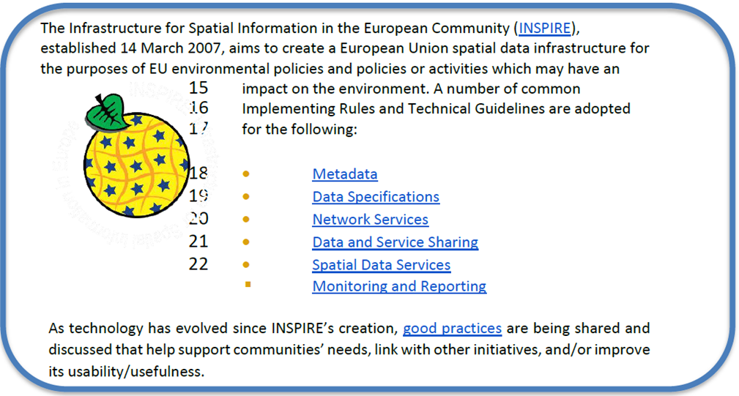Final-Report.pdf](https://frontiersi.com.au/wp-content/uploads/2020/11/P1003-Geodetic-Standards-Final-Report.pdf)

*Figure 6.1 INSPIRE – A European legislative Directive with technical specifications encouraging the use of open standards*

### 

### **Success Indicators for Benefits Realization**

What are the indicators for success from which tangle benefits can be assessed? Provided below are case standards implementation case studies showing ROI, cost savings, and new efficiencies benefitting one or more organizations.

* The OGC WaterML 2.0 standard, was developed in a working group organized jointly between OGC and the World Meteorological Organization (WMO). WaterML was implemented to more easily integrate a multitude of hydrologic surface and groundwater observations to improve local to global water resource monitoring. See: [Swimming in Data: OGC’s WaterML 2.0 Quenches New Zealand’s Thirst for Information Integration | OGC](https://www.ogc.org/blog/3285)
* A [Land Information New Zealand Bathymetry Investigation](http://www.linz.govt.nz/system/files_force/media/pages-attachments/New%20Zealand%20Bathymetry%20Investigation%20October%202015.pdf?download=1) identified open standards such as metadata and IHO standards as a means of reducing duplication of collection, and to minimize associated outlay of operational funding.
* Within the framework of Mexico's statistical and geographical information system, based on good international practices in standardization, INEGI provides the Technical Regulations for coordination and guidance on statistical and geographical matters. f<https://www.snieg.mx/DocumentacionPortal/Normatividad/vigente/nt_ng_frs_feg.pdf>.

1. UN GGIM Integrated Geospatial Information Framework (IGIF) - Strategic Pathway 6 (SP6), <http://ggim.un.org/IGIF/part2.cshtml>
2. What is Interoperability? <https://www.himss.org/resources/interoperability-healthcare>
3. <http://tsapps.nist.gov/publication/get_pdf.cfm?pub_id=101300>
4. adapted from <https://www.usgs.gov/core-science-systems/ngp/ss/product-standards>
5. Open does not necessarily imply free of cost. Depending on a SDO’s business model, costs of developing standards are recovered from membership fees or sales.
6. Specifications may be industry or community developed. Industry-driven specifications typically start as closed or proprietary based on their intellectual property value and a company’s investment in research and development. Some owners of closed specifications make open libraries available for others to read and right, providing a level of openness. As specifications mature, some are released through open licenses to the community as open specifications. Some International and Community standards begin as industry developed open specifications and de facto standards.
7. A Community standard is an official position of the OGC endorsing a specification or standard developed external to the OGC and is considered a normative standard by OGC membership and part of the OGC Standards Baseline. Examples of open specifications that have achieved OGC Community Standard status include the *OGC 3D Tiles Specification* and *OGC Indexed 3d Scene Layer (I3S) and Scene Layer Package Format Specification*. <https://www.ogc.org/standards/community>
8. Examples of endorsed Good Practices include the Defence Geospatial Information Working Group (DGIWG) Comm/TIFF Profile for Imagery & Gridded Data 2.3.1 (OGC Best Practices https://www.ogc.org/docs/bp ) and INSPIRE Good Practice: SDMX for Human Health and Population Distribution (INSPIRE Good Practices https://inspire.ec.europa.eu/portfolio/good-practice-library )
9. De facto standards can be endorsed as international standards over time, for example, *HTML, PDF*, and *GeoJSON* have followed this route <https://whatis.techtarget.com/definition/de-facto-standard> and <https://www.ogc.org/blog/2543>
10. See DIN, “"Economic Benefits of Standardization," 2010, at <http://www.din.de/sixcms_upload/media/2896/DIN_GNN_2011_engl_akt_neu.pdf>
11. See Craglia M. (Ed.), “The Socio-Economic Impact of the Spatial Data Infrastructure of Catalonia,” 2008, at <http://publications.jrc.ec.europa.eu/repository/handle/111111111/7696>
12. NASA Geospatial Interoperability Return on Investment Study (2005) [http://www.ec-](http://www.ec-gis.org/sdi/ws/costbenefit2006/reference/ROI_Study.pdf) [gis.org/sdi/ws/costbenefit2006/reference/ROI_Study.pdf](http://www.ec-gis.org/sdi/ws/costbenefit2006/reference/ROI_Study.pdf)
13. New Zealand <http://www.linz.govt.nz/geospatial-office/about/projects-and-news/productivityreport>
14. A profile may be a locally recommended subset of a standard and/or locally relevant domain lists to be used with a particular standard, such as a list of metadata keywords.
15. The reference model for geographic information standardization (ISO 19101-1, Geographic information -- Reference model -- Part 1: Fundamentals, also available as the OGC Abstract Specification)
16. ISO 19101-1:2014, Geographic information -- Reference model -- Part 1: Fundamentals
17. UN GGIM Integrated Geospatial Information Framework (IGIF) - Strategic Pathway 6 (SP6)
18. For examples of ‘Foundation’ see ANZLIC Australian and New Zealand Foundation Spatial Data Framework [http://www.anzlic.gov.au/foundation_spatial_data_framework.](http://www.anzlic.gov.au/foundation_spatial_data_framework) For examples of ‘Framework’ - See US Federal Geographic Data Committee Framework, <https://www.fgdc.gov/framework/handbook/overview>
19. Refer to ISO Standard “19110:2016 Geographic information — Methodology for feature cataloguing” for more information
20. See also ISO Standard “ISO 25964-1 Information and documentation - Thesauri and interoperability with other vocabularies”. In particular, ISO 25964-2 describes the W3C recommendation SKOS, the Simple Knowledge Organization System.
21. More information can be found online at the Data Interoperability Standards Consortium <http://datainteroperability.org/>
22. www.ogc.org/roadmap
23. Further, [MQTT](https://de.wikipedia.org/wiki/MQTT) is becoming increasingly popular in the IoT universe.
24. <https://www.ogc.org/standards/community>.
25. See<http://www.onegeology.org/technical_progress/technical.html>